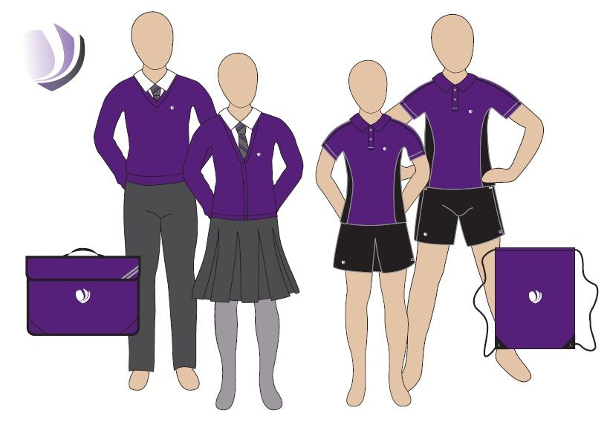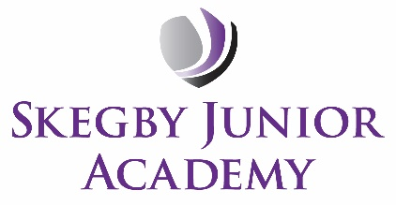

Earrings

* Children are allowed 1 pair of small, plain stud earrings. These are to be removed at home on PE / Forest School days or covered with tape for any newly pierced ears, where earrings cannot yet be removed.

Hair

* Long hair should be tied up and accessories should be academy colours.
* There should be no hair dye or shaved patterns in children’s hair.

Important reminders:

* By joining SJA, families signed the home school agreement which states *“To keep the school successful we ask you to:-Send your child in full academy uniform.”*
* Plain jumpers and cardigans are not part of our uniform policy
* Our spare items in the office can be borrowed in an emergency, but families must not rely on this on a daily basis
* Parents will be invited into school if their child repeatedly fails to follow our Uniform Policy.

Purchasing new items:

* Uniform can be ordered/purchased from our supplier: *Price and Buckland online at price-buckland.co.uk*
* We also have a range of second-hand items available for only £1 each. These have been washed and are still in great condition
* We stock replacement uniform items from our office

Our academy cannot look smart without your support.

The vast majority of our children wear the correct uniform and take pride in representing Skegby Junior Academy.

Thank you to everyone who supports our uniform policy and sends their child/children to the academy looking smart.

**Smart uniform expectations**