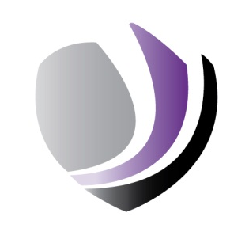
Skegby Junior Academy
End of Year 6 Assessments 2019

% of children achieving age related expectations | Reading | Writing | Maths | Combined | GPS
National | 73% | 78% | 79% | 65% | 78%
Skegby Junior Academy | 45%  (GDS 13%) | 65%  (GDS 13%) | 55%  (GDS 10%) | 42%  (GDS 0%) | 61%  (GDS 13%)

Average Scale Score | Reading | GPS | Maths
National | 104 | 106 | 105
Skegby Junior Academy | 96 | 101 | 100

Progress Scores | Reading | Writing | Maths
Skegby Junior Academy | -4.8 | 0.8 | -2.3

