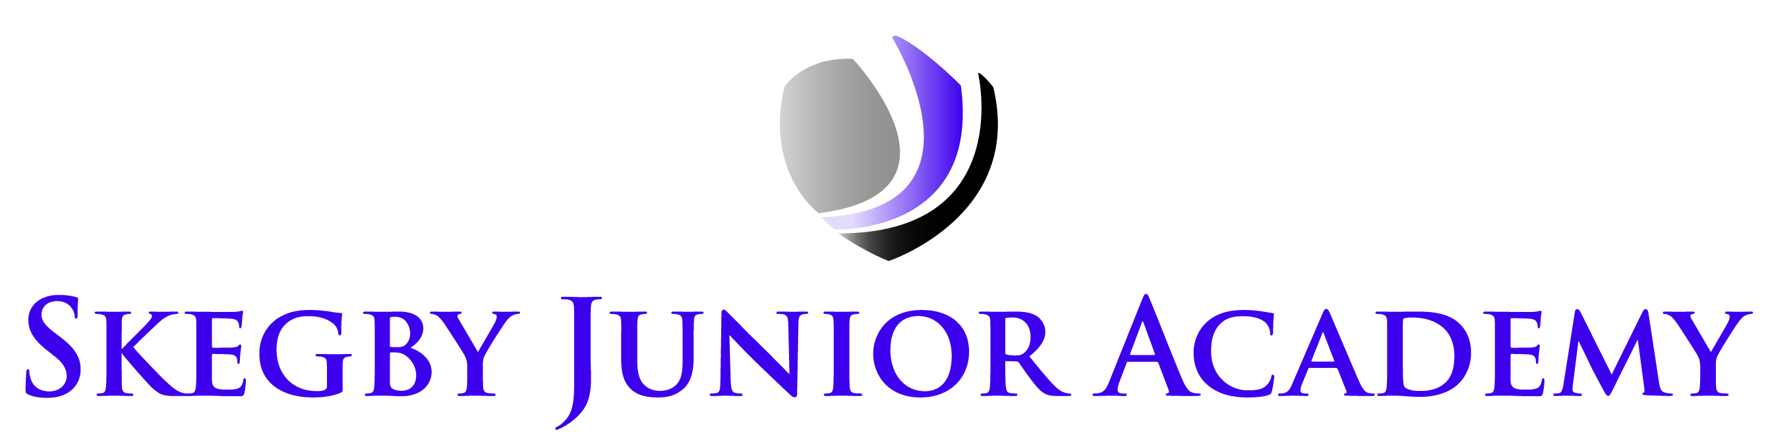
CASHLESS ACADEMY STARTING JANUARY 2017

Dear Parents / Carers,

To further enhance our current sQuid online parent payment system and see even more benefits, I am very excited to write to you about our enhanced sQuid payment system that is currently being set up and will be ready to use from January 2017. At present we use sQuid for school dinner payment, which is very effective but the teachers still spend precious learning time in the mornings collecting in break money and the office & kitchen handle cash for breakfast club, afterschool club and school trips.

The new enhanced system will allow us to take payment from your child’s sQuid account for the following items:
- Breakfast Club £1
- Snack’s for morning break 30p per item (max 2 items per day)
- School dinners £2 per day
- After school club 3-4pm £1, 3-5pm £4
- School trips £as per trip
We will only be able to provide these items listed above if your account is in credit.

To enable us to GO LIVE on 4 January 2017, we need all families to have a sQuid account set up. If your child already has an account, that is great, you are all ready to start seeing the benefits of the enhanced system and just need to ensure you have money in the account by the go live date.
If you don’t currently have an account for your child, please pop in to the office for a letter on how to set up an account or ask your child to see us so that you can set up your account ready for the go live date.
All Free school meals pupils will now need an account too for the enhanced payment options.
If you need any help setting up a sQuid account, please let us know.

Kind regards

Mrs Tina Hamilton
Office Manager

