

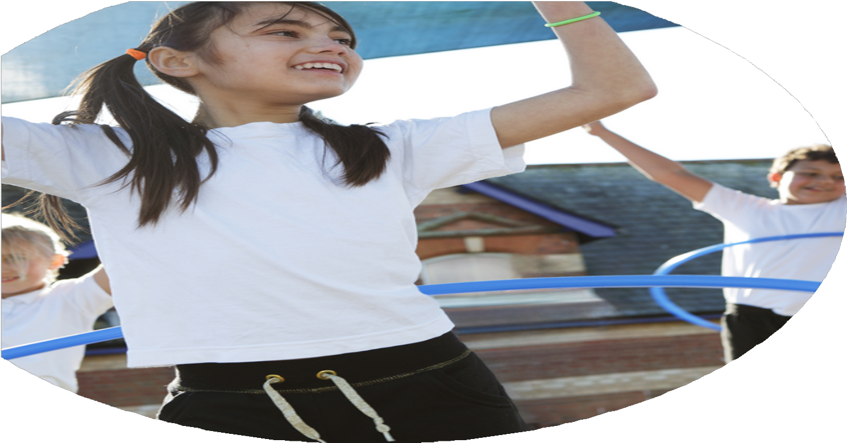
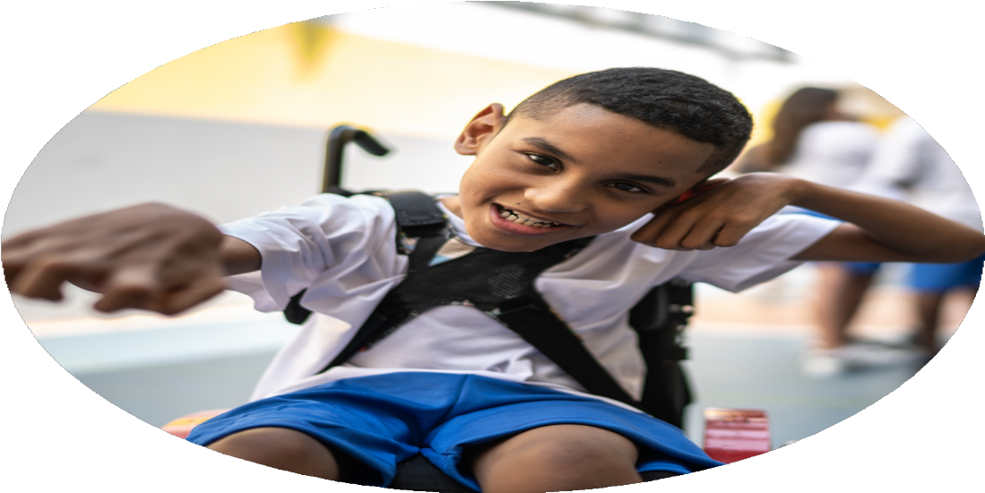




PE Funding

Evaluation Form

Commissioned by

Created by

Images courtesy of Youth Sport Trust

PE Funding Evaluation Form

It is intended that this template should be used as preparation for the completion of the statutory digital reporting tool being introduced this academic year. You can upload data (including swimming) from this template onto this platform once it becomes accessible.
Before you decide how you are going to use the funding for this academic year you should reflect and evaluate the impact of your use of the funding in 2023/24.
All spending of the funding must conform with the terms outlined in the Conditions of Grant document. The template is a working document that you can amend/update during the year.
Based on your evaluation of last year’s funding you should decide what you intend to do this academic year, how you will do it, and what impact you expect it to have.

It is important that the funding is used effectively and based on your school’s needs.
You must use the funding to make additional and sustainable improvements to the PE and sport in your school. You must develop and add to the PESSPA activities that your school already offers.

Summative digital reporting from June 2025 will continue to include swimming and water safety information therefore funding can be used to provide top-up lessons where necessary to ensure pupils meet national curriculum swimming requirements.

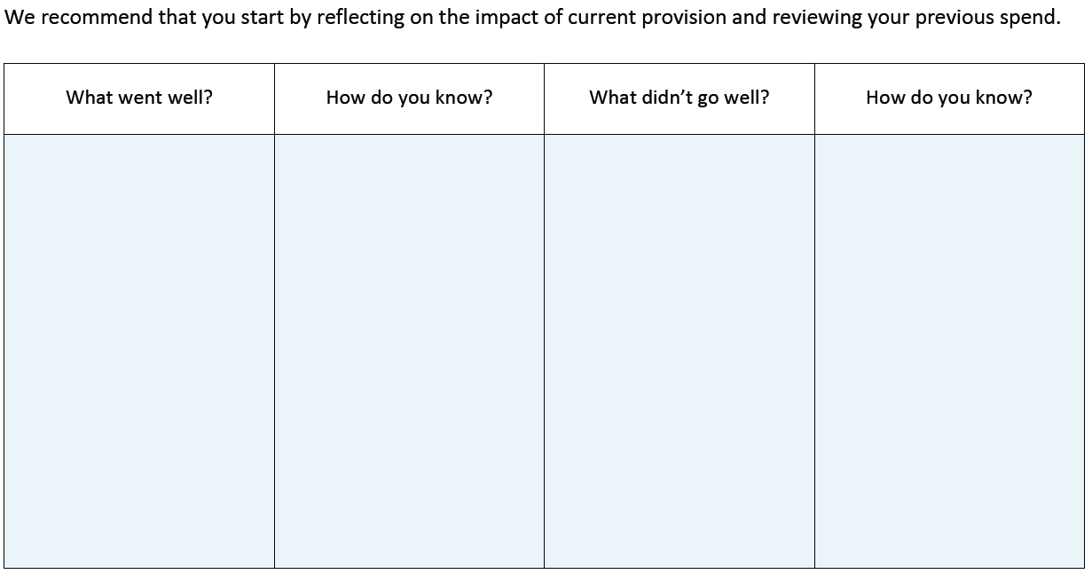
Some (but not many) competitions were introduced and attended through Ashfield games.
Some involved the non-engagers/SEND. Continue as target for 24/25.

Whole school discussions of levels of activity – agreed amongst staff that children are not getting 60 mins a day of physical activity.
Introduce additional, inclusive competitive sports opportunities providing the opportunity for all children to participate
- Get involved in Ashfield games
- GAT competitions
- Competitions with local schools.
- Competitions within school curriculum.

Develop pupil activity to meet 60 minutes a day.
- Playground leader training happened but need to ensure it is then being used consistently.
- Work continues to be needed to ensure opportunities for activity throughout day (moki bands?)

Staff confident to teach their own PE lessons and have experienced activities and teaching of a sport they do not feel as confident in. Staff have been upskilled in areas unique to them.
All staff upskilled in gymnastics using Allison consultancy and then staff taught their own lessons.

Most children across the school attended a club during the year and more signed up throughout the year.
Lots of children who attended were SEND or PP (not tracked during 23/24 – this is next step for 24/25)

Staff CPD
- external, local coaches booked to pair teach with each teacher in an area they feel less confident in.
- Learning walks identified needs.
- Use of Gat support package (3 network development days+ 1 in school bespoke day)
- Use allison consultancy for staff sessions (gymnastics twilight) and pupil sessions (gymnastics and play leaders).

Increased the range of healthy, physical activity opportunities outside of the curriculum in order to engage more children.
- Introduced extra curricular clubs
- Pupil voice to see what children would be interested in.

What are your plans for 2024/25?

Intent
How are you going to action and achieve these plans?

Implementation
Move away from use of coaches teaching PE and return to teachers teaching PE as they have been upskilled in areas they were less confident through CPD and observing how coaches teach. – Use of Power of PE scheme to support this.

More extra-curricular opportunities for children through use of after school clubs.

Monitor attendance of clubs to track % of pupil premium/send/boys/girls attending and engaging.

Introduction of wellbeing days on return from school holidays to ease children’s transition back into school routine.

Equipment audit and ensure school has sufficient resources to teach PE well.

We are moving away from coaches on staff becoming more reliant on own adapted planning but staff voice will be done later in year to ensure staff competence and confidence and quality of lessons remains high. Learning walks will be organised so that PE lead can ensure standards of the curriculum are being met and fed back to SLT. Because staff confidence is high, it would be good to explore more subject specific related equipment so that staff can add more challenge in lessons for children.

Following on from pupil voice, we have started expanding the range of extra-curricular clubs and opportunities available to children. We realise it is important that we are offering clubs for children who are harder to reach or perhaps have barriers to physical activity and so pupil voice will be repeated throughout the year.

Throughout the year we’ve put on a range of clubs and a significant % of SEND and pp children have attended.
Y3/4 Judo: Pupil Premium 45% SEND 20% Girls 25% Boys 75%
Y5/6 Football: Pupil Premium 25% SEND 12% Girls 13% Boys 87%
Y3/4 Football: Pupil Premium 69% SEND 13% Girls 19% Boys 81%
Y5/6 Basketball: Pupil Premium 20% SEND 0% Girls 58% Boys 42%
Y3/4 Dance: Pupil Premium 60% SEND 6% Girls 80% Boys 20%

Focused on well-being and personal and social development through new opportunities for children to experience and raise awareness for different sports. This will help engage children who normally don’t participate in traditional sports clubs to become aware of other opportunities in the local area. Explore options such as parent involvement in clubs e.g. lads and dads to foster greater cohesion between physical activity levels extending from school to home life.
See above related to subject specific equipment.

What impact/intended impact/sustainability are you
expecting?
How will you know? What evidence do you have or
expect to have?
Staff to be more confident in all areas of the curriculum and utilizing more subject specific equipment to increase challenge in lessons and extend skills further for SEND and greater depth learners.

Extend the participation levels of a variety of children and inspire children to take part in physical activity outside of school. Embed opportunities within school to encourage their own pathways to physical activity with their families to encourage sustainability of a more physically active life.

Continue to have dialogue with teachers and staff to target a wider variety of children to benefit from social, emotional and cognitive benefits of clubs. Rotate options of types of clubs available so that all children will get access to participating.

The wellbeing days are held on the first day of each half term to ease transition back into a structured school life. By creating a positive and welcoming environment we endeavor to use physical active learning to guide students to reconnect with their peers in a structured learning environment. For example, we used social UV dodgeball as a new experience and the intent behind that was to support children’s emotional wellbeing through a fun and active game and then staff held workshops and discussed emotional regulation in the classroom but also when active around school.

Through use of subject specific equipment, staff will be able to design lessons with more challenge and extension of skills which will enhance children’s physical development.
Learning walks and staff voice show staff are confident teaching PE.
Pupil voice highlighted that they want to use more equipment more often

Pupil voice to find out which sports children are interested in - After school clubs to provide children with these opportunities. Clubs/Coaches who have led after school clubs have given out leaflets and told children of ways to get involved outside of school.

Analysing registers – see above.

Pupil voice, Conversations with teachers and ELSA’s in regard to certain children’s current wellbeing and how the workshops have affected them.

Equipment audit to show what equipment needs to be ordered.

Staff feedback, data on insight.

What impact/sustainability have you seen?
What evidence do you have?
Learning walks and staff voice show staff are confident teaching PE. Pupil voice highlighted that they want to use more equipment more often – embed more opportunities for the subject specific equipment to be used in the next year. Use PE equipment as reward opportunities next year so children get chance to use it even when it’s not their PE topic, e.g. gymnastics equipment for attendance reward.

Club registers – see above for % of PP and SEND children attending.
Specific competitive opportunities for children with SEND e.g. boccia tournament, multi skills festival, bowling... Pupil voice highlighted which sports children are interested in doing outside of school. After school clubs have been put on to provide children with these opportunities. Clubs/Coaches who have led after school clubs have given out leaflets and told children of ways to get involved outside of school.
Lunch club began in Spring 1 for all children to take part, with a specific focus on those children with additional needs who would benefit from social, emotional and cognitive benefits of clubs/sport. Rotation of activities in lunch club so children can try new sports.

New social experiences given to children on these days include UV dodgeball, gym circuits, sports exercise-a-thon, circus skills, tough runner. Pupil voice showed these were enjoyed by all and were given opportunities to take part in different sporting activities. Following on from pupil voice the PE curriculum for 25/26 will be adapted to include new sports children enjoyed e.g. tag rugby for year 5/6. Staff voice confirm behaviours on return to school have been good.

Some new equipment ordered throughout year. Equipment audit shows we have lots of subject specific equipment in school now. Next year to ensure equipment is being used to challenge GD learned and include all SEND learners.

Staff are confident in all areas of the curriculum in the areas they teach and utilize subject specific equipment to increase challenge in lessons and extend skills further for SEND and greater depth learners.

Extend the participation levels of a variety of children and inspire children to take part in physical activity outside of school. Embed opportunities within school to encourage their own pathways to physical activity with their families to encourage sustainability of a more physically active life.
Continue to have dialogue with teachers and staff to target a wider variety of children to benefit from social, emotional and cognitive benefits of clubs. Rotate options of types of clubs available so that all children will get access to participating.

The wellbeing days are held on the first day of each half term to ease transition back into a structured school life. By creating a positive and welcoming environment we endeavor to use physical active learning to guide students to reconnect with their peers in a structured learning environment

Through use of subject specific equipment, staff will be able to design lessons with more challenge and extension of skills which will enhance children’s physical development.

