
Year 3 & 4
Summer 1
Skegby Junior Academy – Knowledge Organiser

Why do so many people go to the Mediterranean for their holidays?
Geography Topic:
Key vocabulary
Background understanding for teachers and parents
Mediterranean Sea | This is a sea which is connected to the Atlantic Ocean, it is completely enclosed by land.
Continent | The world’s main continuous expanses of land (Europe, Asia, Africa, North and South America, Australia, Antarctica)
Climate | The weather conditions in a certain area.
Country | A nation with its own government.
Physical features | Natural features on the Earth’s surface like seas, mountains and rivers.
Human features | Things that are made or built by humans like houses, roads and bridges.
Territory | An area of land not attatched to its ruling state.
Tourist | A person who is travelling or visiting a place for pleasure
Coastline | The land where it meets the sea, the coast.
Cuisine | A style or method of cooking specific to a particular country or region.

The Mediterranean is a geographic area which is defined by the Mediterranean Sea. The countries which are classed as Mediterranean have a coastline with the Mediterranean sea. There are 22 countries/territories in the Mediterranean.
It is a popular tourist holiday destination, people from around the world visit this area due to its outstanding beauty, variety in culture and beautiful beaches.

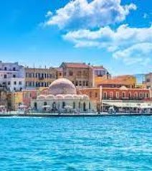
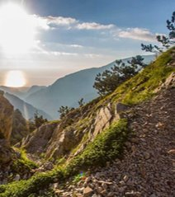
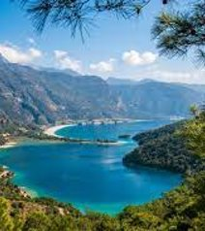
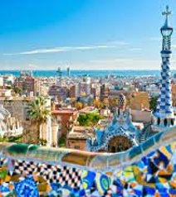

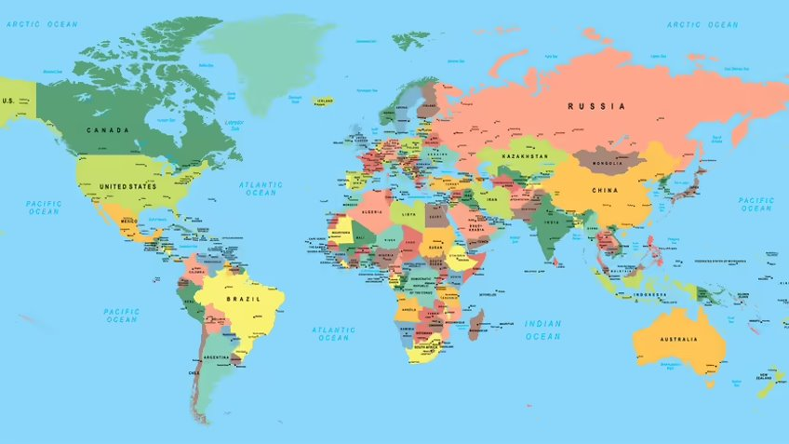
United Kingdom

The Mediterranean

Countries/territories in the Mediterranean
Spain |  | France | Italy
Slovenia |  | Monaco | Malta
Croatia |  | Gibraltar | Bosnia and Herzegovina
Montenegro |  | Albania | Greece
Turkey |  | Syria | Lebanon
Israel |  | Cyprus | Morocco
Algeria |  | Tunisia | Libya
Egypt

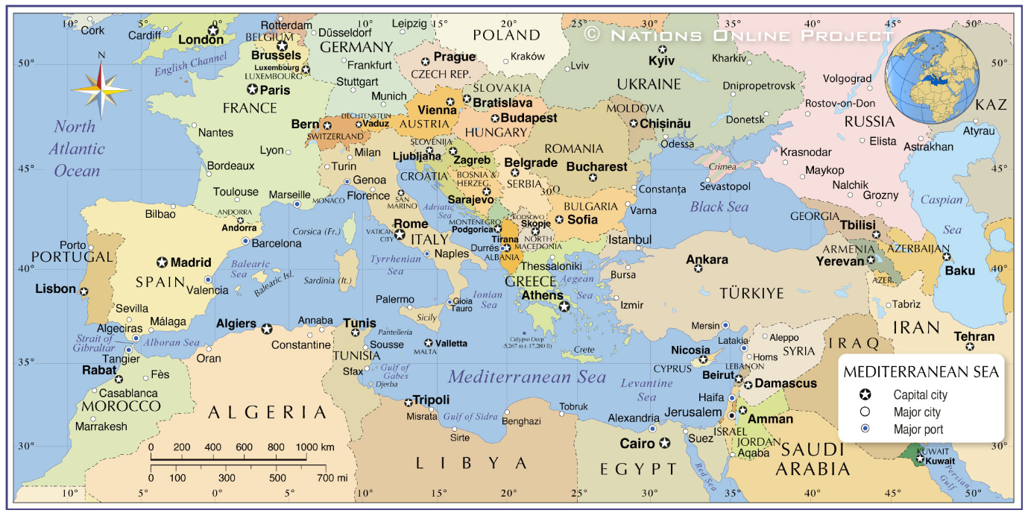
Map of the Mediterranean

Class Countries:

Each class will be focusing on one country from the Mediterranean. They will be researching and working on creating a stall for the Mediterranean showcase we will be holding at the end of the half term. Parents and carers will be invited to come and look around our showcase, which will have children’s work on show but also music and food from the class countries. A true celebration of the children’s work!
Maple | Turkey | 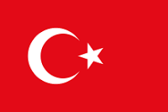
Silver Birch | Morocco | 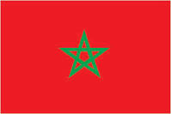
Willow | Spain | 

