
Year 3 & 4
Summer 2
Skegby Junior Academy – Knowledge Organiser

Why is Greece always in the news?
History Topic:
Key vocabulary
Background understanding for teachers and parents
Ancient Greece | A civilisation existing from the 12th to the 9th centuries BCE
Acropolis | a citadel or fortified part of an ancient Greek city, typically one built on a hill.
Greek Mythology | a collection of myths, especially ones belonging to a particular religious or cultural tradition.
Democracy | a system of government by the whole population or all the eligible members of a state, typically through elected representatives.
Physical features | Natural features on the Earth’s surface like seas, mountains and rivers.
Human features | Things that are made or built by humans like houses, roads and bridges.
BCE | Before common era (the year 0)
Polytheistic | This means that they believed in several gods.

Ancient Greece was a north-eastern Mediterranean civilisation, existing from the 12th to the 9th centuries BCE. At its peak, ancient Greece ruled much of Europe and western Asia. The Greeks came before the Romans and a lot of Roman culture was influenced by the Greeks.
Ancient Greece formed the foundation of much of Western culture today. Everything from government, philosophy, science, maths, art, literature and even sports!

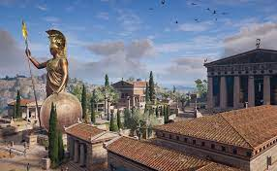
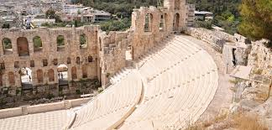
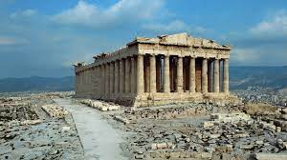

Amphitheatre
Acropolis

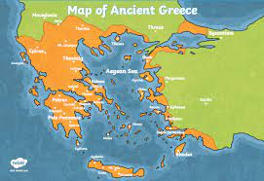
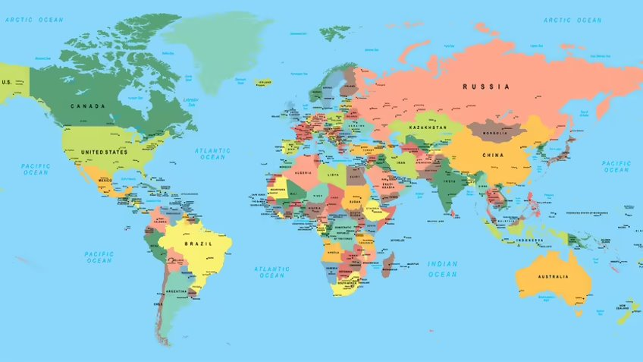
United Kingdom

Greece

What did the Greeks do for us?
The Trojan Horse
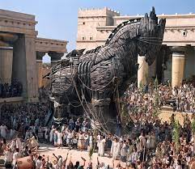

The trojan horse was a wooden horse said to be used by the Greeks during the Trojan war to enter the city of Troy and win the war! Soldiers were hidden inside the horse as it was brought into the city. Many historians believe that this story was actually a myth and not a real event.
Western Philosophy – the love of knowledge!
Olympics – The first Olympics began in the year 776BCE, some of the first games were boxing, wrestling, and running.
Marathon – The original marathon covered 260 kilometres of rugged terrain in less than two
Alarm clock – This alarm clock was made with water, filling into a tube and spilling over!
Umbrellas – These were reserved for women first, but as time passed men started to use them as well. It was considered a sign of wealth.
Cartography (Maps) – Maps were invented by the ancient Greeks; they were the first to write and draw a map.
Western Theatre (drama) – Ancient Greeks were the first to create dramas, they were called dithyrambs, these were songs for the god Dionysus

Ancient Greek Gods
The ancient Greeks believed in many gods! This means they were polytheistic.


