
Year 5 and 6
History Topic:
Who were the Mayans and what have we learned from them?
Key vocabulary
Summer 2
Skegby Junior Academy – Knowledge Organiser

Background understanding for teachers and parents
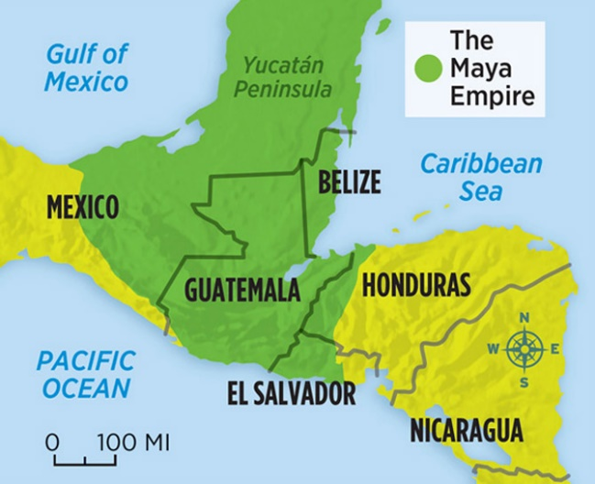
The first Mayan civilisations were uncovered by archaeologists in the 1830s. The area had been taken over by the rainforest.
The Mayan Empire, which was located in tropical, central America (Southern Mexico, Guatemala and Belize), reached the peak of its power and influence around the sixth century A.D.
The Maya excelled at agriculture, pottery, writing, calendars and mathematics. They left behind an astonishing amount of impressive architecture and symbolic artwork.

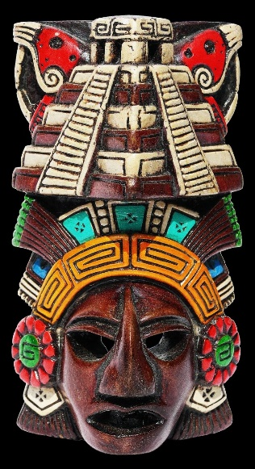
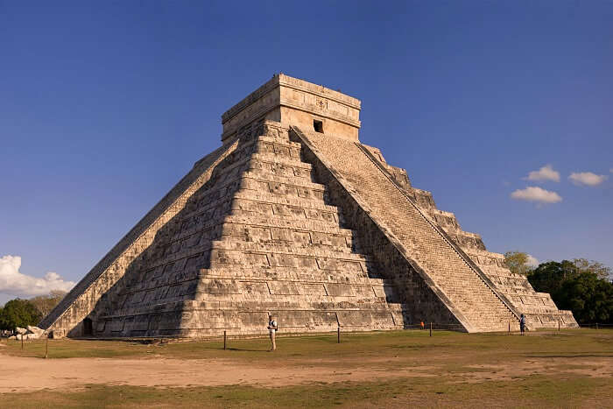
Monument | A structure to commemorate an event or person.
Codices | An ancient manuscript or text.
Calendar | A chart that splits the year into months, weeks and days.
Astronomy | The study of space and the universe.
Cacao beans | Beans that are used to make products like chocolate.
Priest | A minister of a church.
Warrior | A person who is prepared to battle.
Temple | A sacred building, usually used for worship and burials.
Mayan | An ancient civilisation from Central America.

Worry Dolls
A Mayan temple, which would have been used for rituals to worship and honour the gods.
Mayan masks like this one were used as decoration in the home and were to be worn to important events in the community.
Mayan children told their worries to their own hand-made Worry Doll, placing them under their pillow when they go to bed at night. By morning the dolls have gifted them with the wisdom and knowledge to eliminate their worries.


