
Year 5/6
History Topic:
Were Vikings always vicious and victorious?

Summer 1
Skegby Junior Academy – Knowledge Organiser

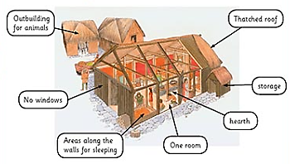
Background understanding for teachers and parents
Norse mythology had a great influence on the lives of the Vikings. There were many influential gods, goddesses and creatures. Each of these had their own characteristics had own lands, where they lived.
Thor  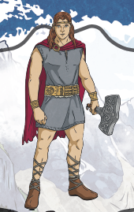  God of thunder. | Loki  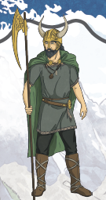  God of mischief. | Odin  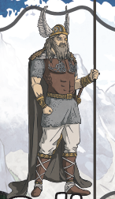  God of wisdom. | Fenrir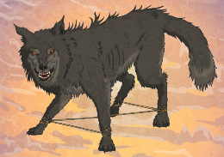  A monstrous wolf. | Sleipnir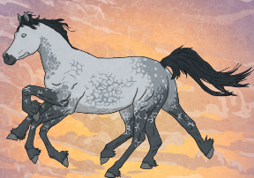  Eight-legged horse, who belongs to Odin.

Key vocabulary

Belief | The trust and acceptance of something being true.
Mythology | Collection of myths(stories) that belong to a specific culture.
Influence | Impact or effect
Culture | Ideas and customs followed by a whole group.
Archaeology | Study of history through artefacts.
Woodwind instrument | Instruments that use air in order to work.
Anglo-Scandinavian | Mixture of Anglo-Saxon and Norse cultures.
Evidence | Information to show or prove an idea.
Enquiry | Question to be answered

Viking Music and Instruments
Stringed instruments
Vikings shared stories and information, through spoken language. Many of the legends about the gods and goddesses were shared and enjoyed through songs.

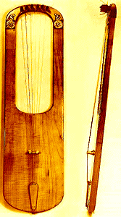
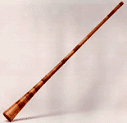

Brass instruments


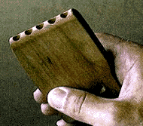
Rhythm instruments
Woodwind instruments

