
Year 6
History Topic:
Were Vikings always vicious and victorious?

Key vocabulary
Summer 2
Skegby Junior Academy – Knowledge Organiser

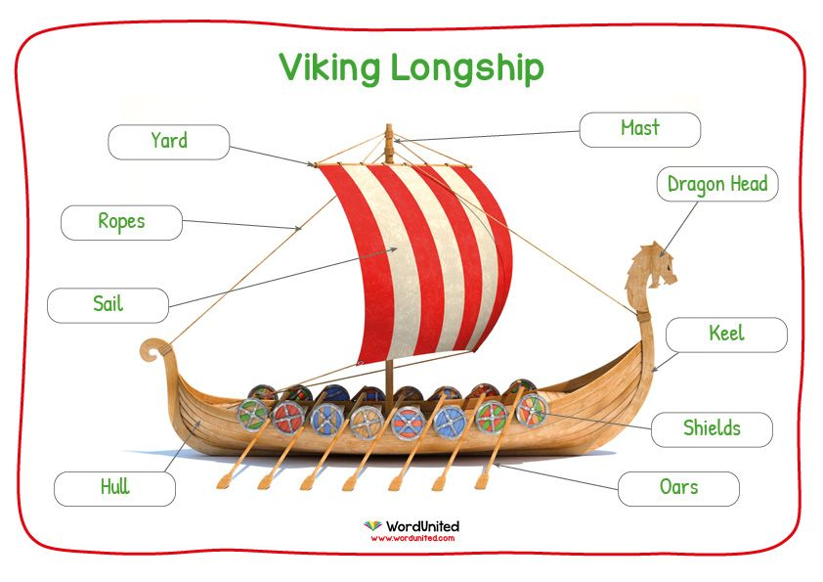
Background understanding for teachers and parents
The Viking age in European history was from about AD700 to 1100. During this period many Vikings left their homelands in Scandinavia and travelled by longboat to other countries, like Britain and Ireland. When the people of Britain first saw the Viking longboats they came down to the shore to welcome them. However, the Vikings fought the local people, stealing from churches and burning buildings to the ground.
The people of Britain called the invaders 'Danes', but they came from Norway and Sweden as well as Denmark. The name 'Viking' comes from a language called 'Old Norse' and means ‘a pirate raid’. People who went off raiding in ships were said to be 'going Viking'. But not all the Vikings were bloodthirsty warriors.

793 | First Viking attack happens in Dorset
793 | Vikings attack the monastery of Lindisfarne
829 | Wessex becomes the Supreme Kingdom
851 | Athelstan, son of the king of Wessex, defeats a Viking fleet in battle
866 - 77 | Invasion of the Great Danish (Viking) Army
867 | The Vikings kill rival kings of Northumbria and capture York – The city becomes Jorvik, the Viking capital in England
878 | Wessex is overrun by Vikings and King Alfred goes into hiding
886 | England is divided – The Saxons retain the west, while the east was to be Viking territory - later known as the 'Danelaw' - where the English and Vikings were equal in law.
926 | Eastern England is conquered by the Saxons
927 | Athelstan, king of Wessex, takes York from the Vikings
939 | Athelstan, first king of all England dies
954 | Eric Bloodaxe, the last Viking king in England, is forced out of Jorvik (York)
Ragnar Lodbrok | The most important Viking leader and the most famous Viking warrior, Ragnar Lodbrok led many raids on France and England in the 9th century.
Erik the Red | One of the most bloodthirsty among all of the Vikings

Invaders  Raiders | a person or group that invades a country, region, or other place  person who attacks an enemy in their territory
Danelaw | The area of England ruled by the Vikings
Fertile/ unfertile | producing or capable of producing abundant vegetation or crops – or not
Longship | A Viking ship with a sail and oars, also called a dragon-ship
Monastery | The building where monks live
Decade  century | 10 years  100 years
Berserker | an ancient Norse warrior who fought with wild or uncontrolled ferocity.
sax | a small sword, fighting knife or dagger
Boss | Middle of shield
Fjord | a long, narrow, deep inlet of the sea between high cliffs
contrast | Differences between

Timeline of key events
Key people from the time

