
Year 3 & 4
History Topic:
How did the Victorian period change Skegby?
Spring 2
Skegby Junior Academy – Knowledge Organiser

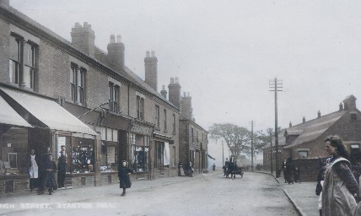
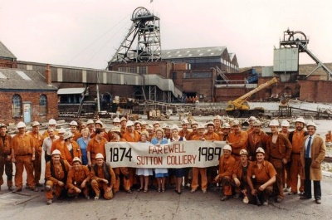
Background understanding for teachers and parents
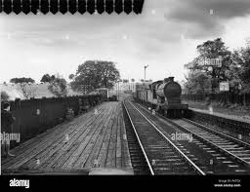
The huge increase in the population of Skegby from 805 people in 1869 to over 3,000 people in 1884, meant that new housing was needed in the immediate area. The increase in people was all due to the jobs available in the mines all over the area. The population of Stanton Hill and Skegby continued to rise, and it became very cosmopolitan. However, because of the sudden influx of new people this caused tension and people started to fight over resources especially essentials, such as water.
1815 | Davy lamp was invented
1867 | Teversal Colliery opened – started production in 1869.
1869 | Population of Skegby/Stanton Hill was 805
1874 | Sutton Colliery opened
1875 | Silver Hill Colliery opened.
1877 | 132 houses built by the mining company, becoming Cooperative Street, Institute Street and Cross Row
1884 | Population of Skegby/Stanton Hill was over 3,000
1899 | Stanton Hill infant school opened.
1901 | Skegby Railway station opened.
1966 | Stanton Hill infant school closed.
1968 | Skegby Railway station closed.
1980 | Teversal Colliery closed.
1989 | Sutton Colliery closed.
1992 | Silver Hill Colliery closed.
2004 | ‘Testing for Gas’ commemorative statue placed on the Teversal Trails.
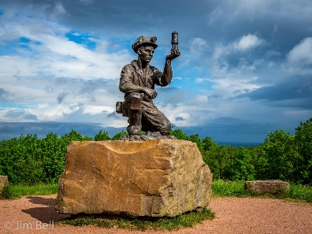
Mine | An excavation in the earth to extract something e.g. Coal
Coal | A grey-black material which can be burnt and used as fuel.
Colliery | A coal mine and the buildings and equipment associated with it.
Coal Face Miners | People who would dig the coal out of the ground.
Lamp room workers | These men would fill and clean the lamps ready for the next person to use.
Coal pickers | These men would take the coal that the miners had dug and load it onto mine carts to be taken to the surface
Davy Lamp | A lamp designed to keep miners safe from explosions from gases.
Victorian period | A time when Queen Victoria was on the throne of England between 1837 and 1901.

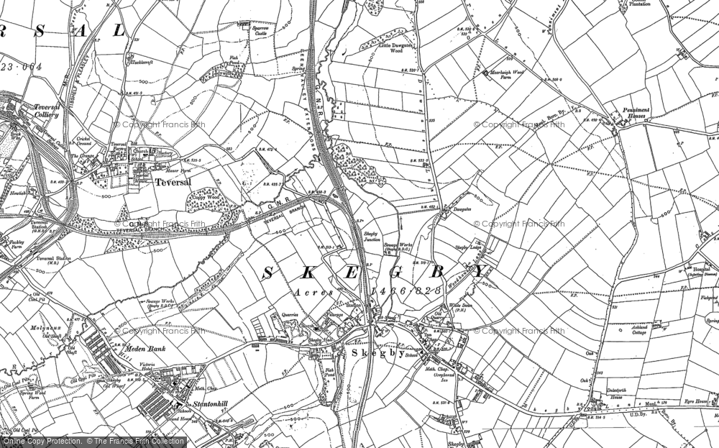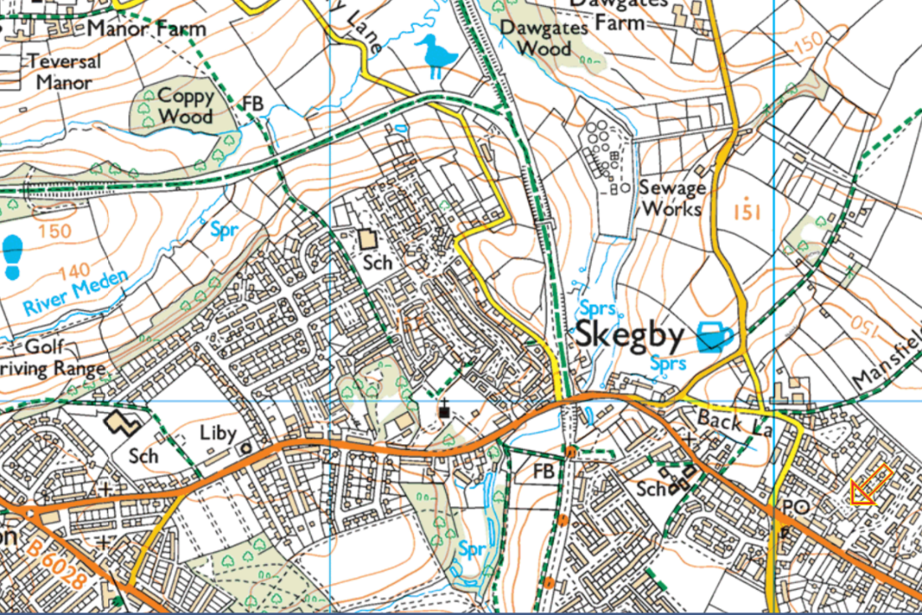
Key vocabulary
Timeline of key events
Maps of Skegby

