Spring 1
Year 3/4
Skegby Junior Academy – Knowledge Organiser

Background Understanding
What makes the earth angry?

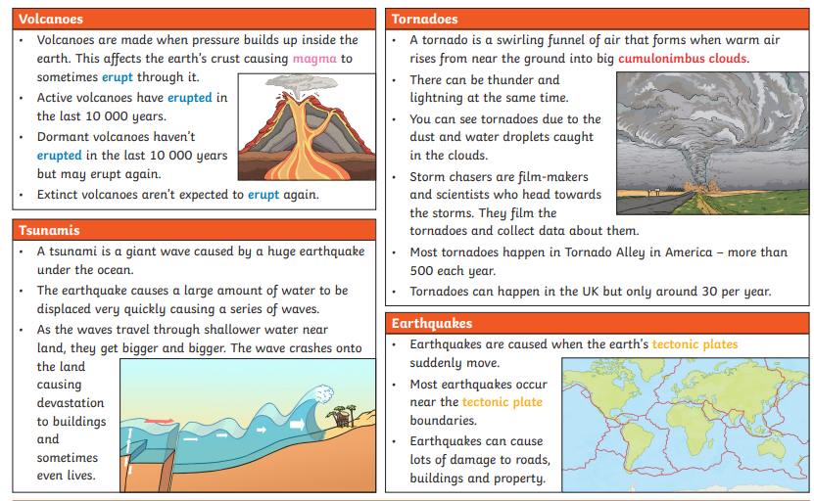

Geography:

Key Vocabulary
Erupt | To suddenly burst out causing lava to explode out of the earth’s surface.
Lava | The molten, fluid rock that erupts from a volcano.
Magma | Hot fluid or semi-fluid below the earth’s crust.
Molten | Something made into a liquid by heat.
Tectonic plates | Plates that make up the surface of the Earth. Study of their movement is called plate tectonics.
Active | A volcano that has erupted in the last 10,000 years.
Dormant | A volcano that hasn’t erupted for 10.000 years but may erupt again.
Extinct | A volcano that is not expected to erupt again.
Tsunami | A giant wave caused by a huge earthquake
Earthquake | Caused when the earth’s tectonic plates suddenly move
Tornado | A swirling tunnel of air that forms when warm air rises from near the ground into big cumulonimbus clouds
Cumulonimbus clouds | Huge clouds of air that are part of a tornado


