
449AD | Angles and Saxons first arrive in Britain
590s-700AD | Anglo-Saxons convert to Christianity
787AD | Viking invasions begin
878AD | Establishment of the Dane Law
957-975AD | England united under King Edgar
1016AD | Cnut becomes king of England
1016-1042AD | England ruled by Danish kings
1066AD | The Norman Conquest

Timeline of key events
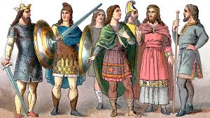 | Anglo-Saxons – a group of people who immigrated to England from northern German and southern Scandinavia.
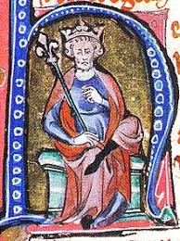 | King Cnut  Cnut the Great, also known as Canute, was king of Denmark, England and Norway, often referred to together as the North Sea Empire during his rule.

Year 5/6
The Anglo-Saxons were a cultural group who inhabited England from the 5th Century. They came from northern Germany and southern Scandanvia. The indigenous British groups adopted many aspects of Anglo-Saxon culture and language. The Anglo-Saxons established the Kingdom of England and the modern English language owes almost half its words to their language. The Anglo-Saxon Britain lasted until 1066 when the Normans conquered Britain.
Background understanding for teachers and parents
History Topic:
Were the Anglo Saxons really smashing?

Key vocabulary
Key people from the time
Spring 1
Skegby Junior Academy – Knowledge Organiser

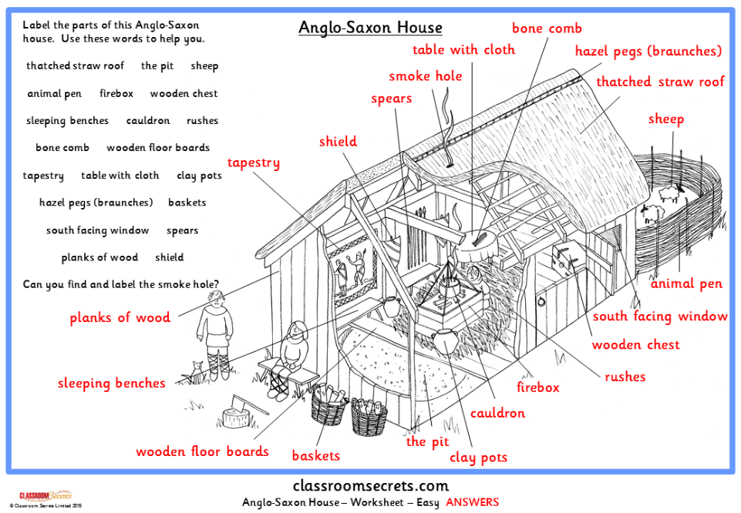
Anglo-Saxon | Immigrants from northern Germany and southern Scandinavia who came to Britain to live in around 449AD
Dane Law | Laws from the Danes (Denmark) that were adopted in England.
A settlement | A place where people live – from a single dwelling to a city.
Establishment | he action of establishing something or being established.
migration | Movement from one place to another in order to settle there
pagan | A person who follows a religion that is not a major religion
runes | Alphabet consisting of between 26-33 letters used to write Old English
Settler | People who migrate to a new place. When people start a community, this is a settlement
thatch | The craft of building a roof with dry vegetation such as reeds and straw
wattle-and-daub | The weaving of small wooden branches with mud, straw, horse hair and dung to create walls

