
Year 5/6
Background understanding for teachers and parents
Geography Topic:
Autumn
Skegby Junior Academy – Knowledge Organiser

Why should the rainforest be important to us all?

Key vocabulary
Rainforests are lush, warm, wet habitats. Trees in the rainforest grow very tall because they have to compete with other plants for sunlight. Kapok trees, which are found in tropical rainforests around the world, can grow to 200 feet.
The Amazon Rainforest
The Amazon covers a huge area (6.7 million sq km) of South America. Nearly 60% of the rainforest is in Brazil, while the rest is shared among eight other countries.
The Amazon Rainforest not only the largest rainforest in the world, it is the world’s richest and most-varied biological reservoir, containing several million species of insects, plants, birds, and other forms of life, many still unrecorded by science.
Rainforests | dense forest rich in plants and animals, usually found in the tropics
Extinction | a species, family, or other group of animals or plants dying out, disappearing.
Endangered | In danger of becoming extinct because of the loss of homes, food or hunting.
Forest Floor | The ground beneath the trees of a forest, consisting of roots, soil, and decomposing  organic matter.
Understorey | Shrubs and small trees under the canopy of the trees.
Canopy | Branches and leaves that spread out at the tops of trees in the woods.
Emergent | The top layer of the forest. Here, trees as tall as 60 meters (200 feet) dominate the skyline.
Humid | high level of water vapour in the atmosphere
indigenous | Originating or occurring naturally in a particular place; native
Species | A class of things of the same kind with the same name.
Vulnerable | A species in high risk of extinction in the wild
Deforestation
Every six seconds, an area of rainforest the size of a football pitch is cleared. If the World continues at the current rate, half the rainforest will be gone in 2050. Gorillas and many other beautiful animals are left without a home.

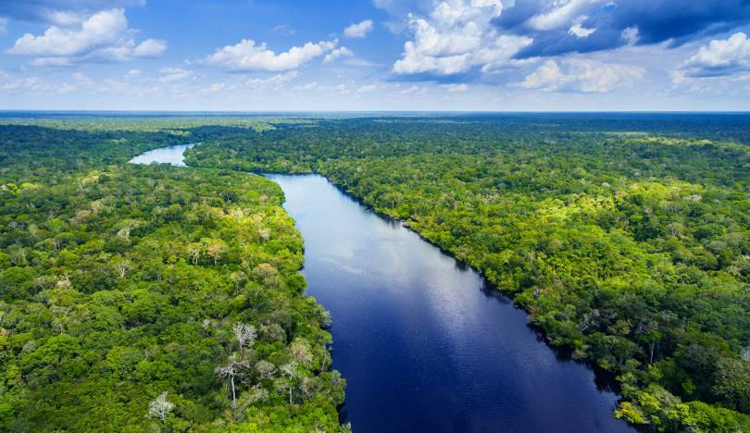
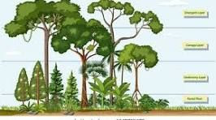

Layers of the Rainforest
The Amazon Rivers – the widest in the world and
the second longest in the world.

