 | Definition
Skara Brae | A stone-built Neolithic settlement, located on the Bay of Skaill on the west coast of Mainland, the largest island in the Orkney archipelago of Scotland. Built in 3810 B.C
Neolithic | The Neolithic is the youngest part of the Stone Age. The Neolithic period is the time when farming was invented and when people started caring for animals, such as cows, sheep and pigs. It is also when the first started to live in large settlements
Hunter-gatherers | Stone Age hunter-gatherers had to catch or find everything they ate. They moved from place to place in search of food. Early Stone Age people hunted with sharpened sticks. Later, they used bows and arrows and spears tipped with flint or bone
Cave paintings | A prehistoric picture on the interior of a cave, that is often on the walls or ceilings. They often depict animals and hunter-gatherers.
Tools | Stone Age tools included hand axes, spear points and later bow and arrows for hunting large game. Scrapers were used to prepare animal hides for clothing and food for eating. Not all Stone Age tools were made of stone.
Stonehenge
Avebury
Cresswell Craggs
Cullerlie Stone Circle
Hordon Edge
Ring of Brodgar
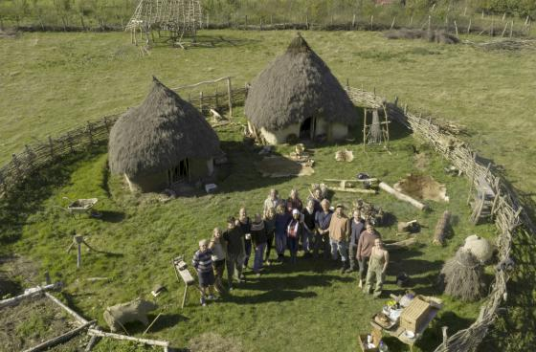
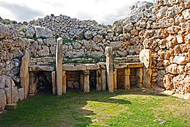
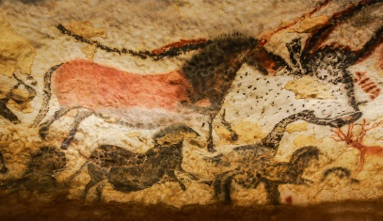

Famous Stone Age Landmarks in Britain
The Stone Age marks a period of prehistory in which humans used primitive stone tools. Lasting roughly 2.5 million years, the Stone Age ended around 5,000 years ago when humans in the Near East began working with metal and making tools and weapons from bronze. During the Stone Age, humans shared the planet with a number of now-extinct animals, including mammoths, sabre tooth tigers and cave lions.

Background understanding for teachers and parents
Autumn 1
Year 3/4
Who first lived in Britain?
History Topic:
Skegby Junior Academy – Knowledge Organiser
Key Vocabulary

