
Year 5/6
Background understanding for teachers and parents
Geography Topic:
Key people
Autumn
Skegby Junior Academy – Knowledge Organiser

Why do people want to travel to Brazil?
Key vocabulary
Brazil is a developing country on the continent of South America. It has a large area of rainforest covering the northern part of the country. We will be learning about Brazil’s geography as well Brazilian life in the capital city of Rio de Janeiro. We will also cover cultural aspects such as art. In the second half of the term we will investigate the rainforest habitat and look at deforestation and how it has decreased in size over the past few years, including the loss of habitat.
South America | A continent in the western hemisphere, mostly south of the equator. It has an area of 17.84 million km^{2.} and a population of around 422.5 million people
Equator | An imaginary line drawn around the middle of the earth dividing the planet into a northern hemisphere and a southern hemisphere.
Developing country | A poor agricultural country that is seeking to become more advanced economically.
Landmark | An object/feature of a landscape or town that can be easily seen and recognised.
Capital city | The city in a country which has the seat of government.
Tourist attraction | A place of interest where tourists typically visit.
Continent | Any of the world’s main land masses. There are 7 continents in the world.
Physical features | This is the branch of geography that deals with natural features
Human features | This branch of geography deals with how human activity affects or is influenced by the earth’s surface.
Climate | Climate is the long-term weather pattern in a region.
Economics of a country | The production, distribution, and consumption of goods, products and services to show how well a country is doing.
Favela | Favela is a name for several types of working-class neighbourhoods in Brazil, which means slum or ghetto.

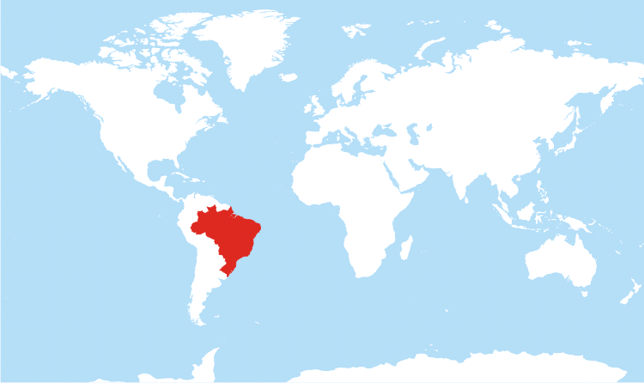
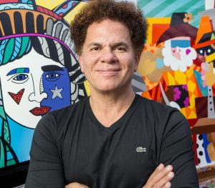
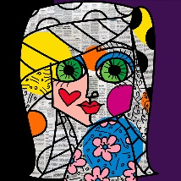

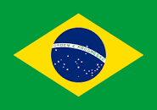
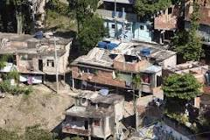
Brazil’s flag
Favela
Romero Britto is a Brazilian pop artist. Born in 1963 in Recife, Brazil. He is the founder of the Happy Art Movement. He uses bright colours and patterns in his art as a visual expression of his hope, dreams and happiness.
Brazil on a world map

