
Science Topic:
How can I be a scientist?
Skegby Junior Academy – Knowledge Organiser

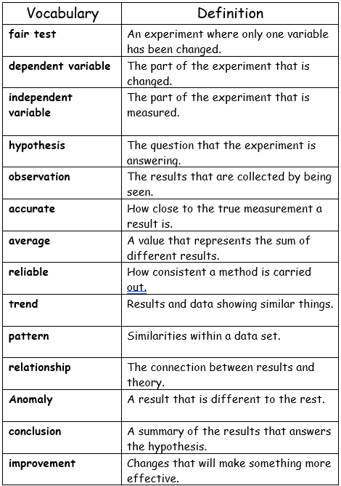
Try being a scientist at home – have a go at the experiments, remembering to follow the scientific method below!

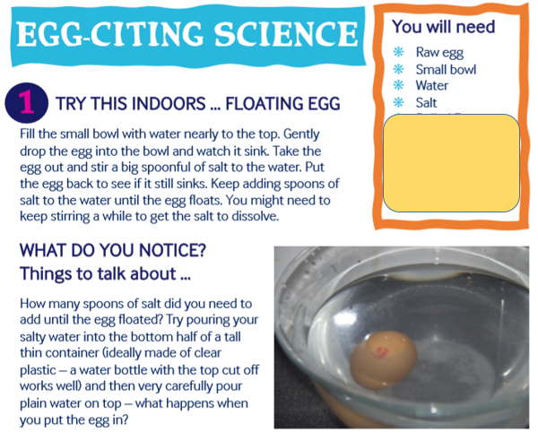

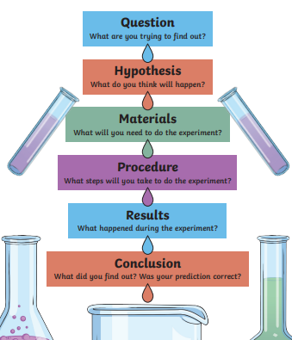

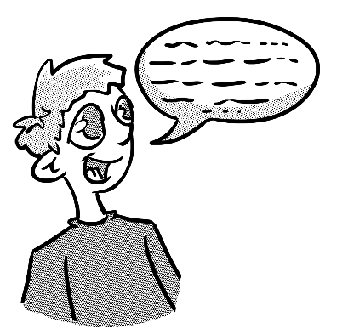
Tell a family member how to…
Introduction
(explain what you will be talking about)
Example
(give an example to support your point)
Sequencing
Firstly,…
Then…
After that…
Conclusion
(sum up the key points)
Introduction
I am going to explain how to make improvements to my experiment.
Example
For instance, how could I make the results more reliable?
Explanation
Firstly, I would practice starting and stopping the stopwatch accurately. Next I would drop the spinner from the top of the stairs. This would make the time to drop longer and help me time it more accurately. Finally, I would repeat each test five times to make my average times more reliable.
Conclusion
Making improvements to the measurements that I take will improve the accuracy and reliability of the results.
Tell a family member how to…
Tell your partner how to make improvements to an experiment.

Useful conjunctions
Firstly,…
Next,…
After that,…
Finally,…
In conclusion,…
Therefore,…
Consequently,…
Furthermore,…
So,…
Therefore,…

