OS Symbol | Symbols on a map to represents various features of the landscape. They make the map easier to read.
Capital city | The main city in a country, usually where its government in held.
Village | A group of houses and other buildings (such as a shop, pub, post office), larger than a hamlet but smaller than a town.
Human Features | Things that have been built or created by humans e.g. houses, shops, high-rise buildings
Physical Features | Things that occur naturally in the landscape e.g., forests, mountains, rivers.
Equator | An invisible line which goes around the centre of the earth. Countries which sit on the equator usually have hotter climates.

Skegby Junior Academy – Knowledge Organiser
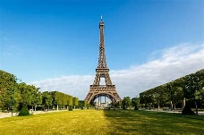  Eiffel Tower | A wrought iron structure built in 1887 by Gustave Eiffel. It is 300 metres high!
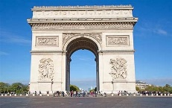  Arc de Triomphe | A ceremonial arch at the top of a famous road in Paris. It was completed in 1836.
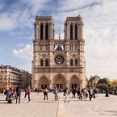  Notre Dame  Cathedral | A gothic style place of worship. It was built in 1163!
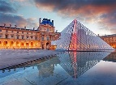  The Louvre Museum | This is a national art museum in Paris – it houses the very famous Mona Lisa painting!
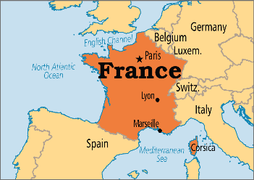
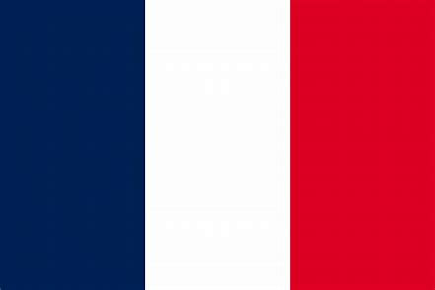
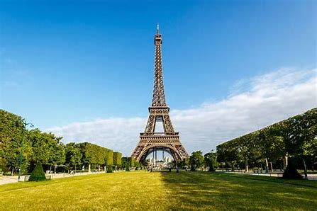
Geography Topic:
Where would you choose to build a city?
Summer 2
Year 3/4
Most major cities in Europe are built around rivers. They are important for transport, trade and tourism. Rivers have been harnessed to suit the needs of people and the way we use them has changed over time: from supplying food and water and transport, to giving us leisure activities. This half term we are focusing on Paris. Learning about their culture, food, architecture and physical features of the major European city.
Background understanding for teachers and parents
Famous landmarks in Paris, France
Key Vocabulary

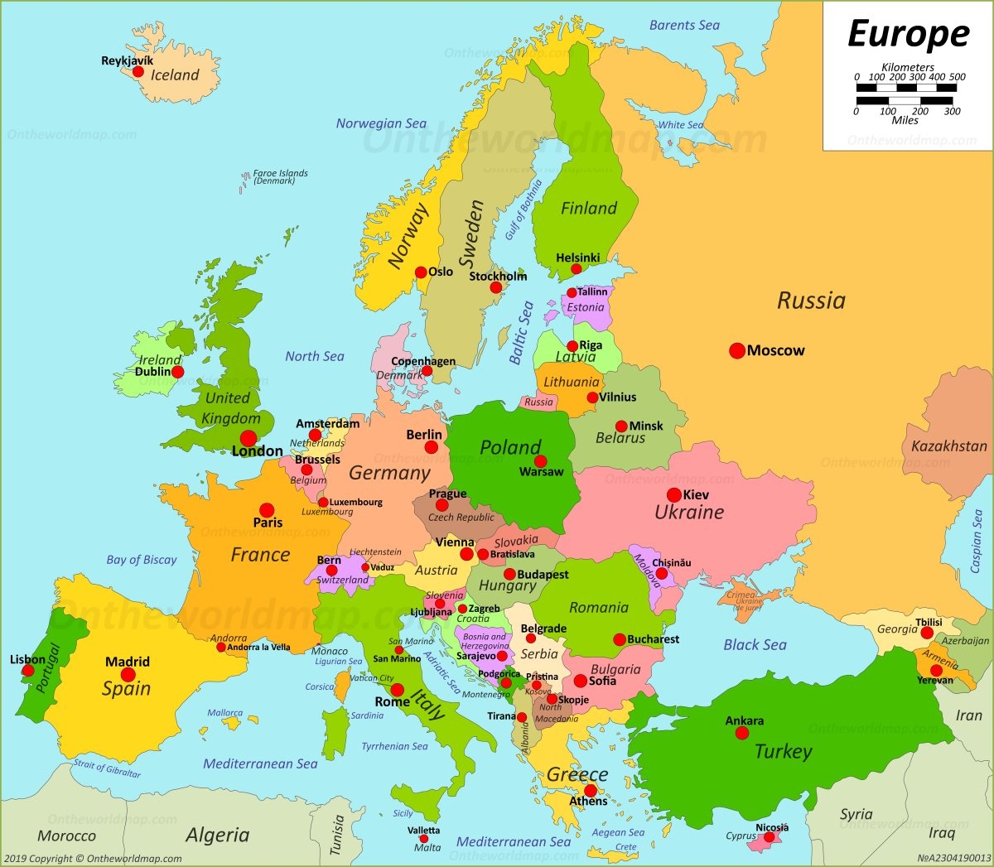
Summer 2
Year 3/4
Geography Topic:
Skegby Junior Academy – Knowledge Organiser
Where would you choose to build a city?

