Skegby Junior Academy – Knowledge Organiser
Year 5 and 6
Summer 2
Geography Topic:
I’m a Skegby pupil, get me out of here!
Our Local Area
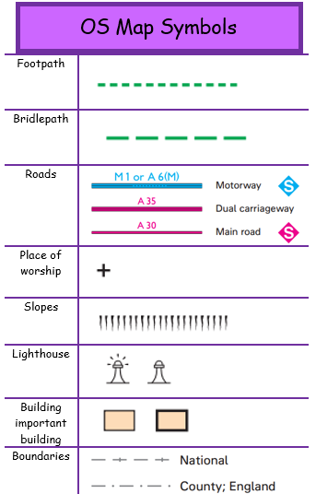
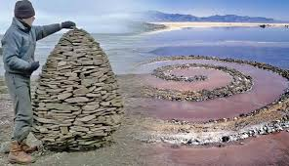
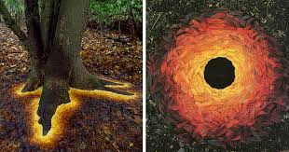
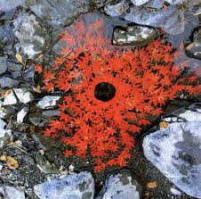
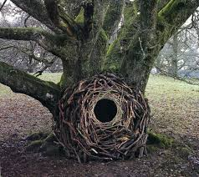
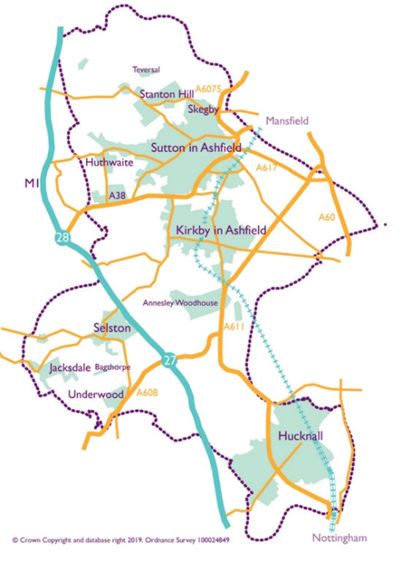
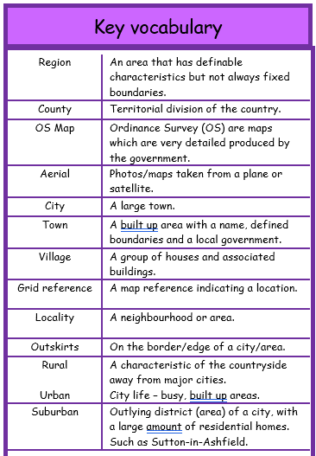
Andy Goldsworthy
Andy Goldsworthy OBE is an English sculptor, photographer, and environmentalist who produces site-specific sculptures and land art situated in natural and urban settings.
Our local area is called Ashfield, it is situated in western Nottinghamshire. Ashfield is made up of several towns and villages : Annesley, Annesley Woodhouse, Hucknall, Huthwaite, Jacksdale, Kirkby-in-Ashfield, Selston, Skegby, Sutton-in-Ashfield, Stanton Hill, Teversal and Underwood. It covers around 42.3 square miles. The population of our local area was 127,200 in 2018.

