Key Vocabulary | Definition
Conductor | A material that lets electricity flow.
Insulator | A material that blocks electricity.
Rechargeable | Can be charged with electricity again.
Motor | Turns electrical power to movement.
Wires | Conduct electricity.
Bulb | Turns electricity to light.
Buzzer | Turns electricity to sound.
Switch | Opens and closes to control the movement of electricity.

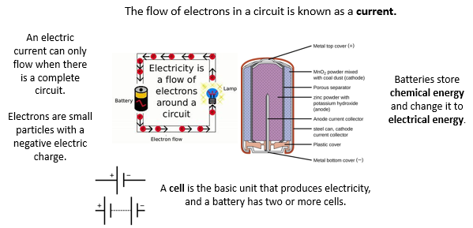

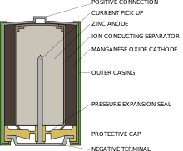

Larger crystals that interlock.
Marble

Voltage is the electrical force which causes electrons to flow around a circuit. It is measured in units called volts (V).

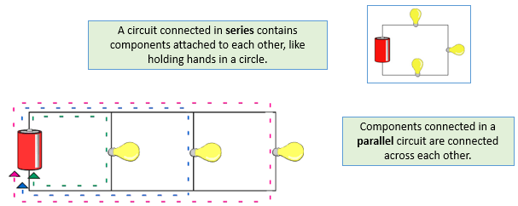
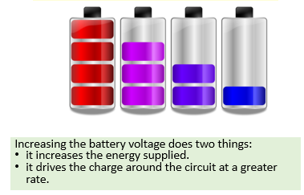

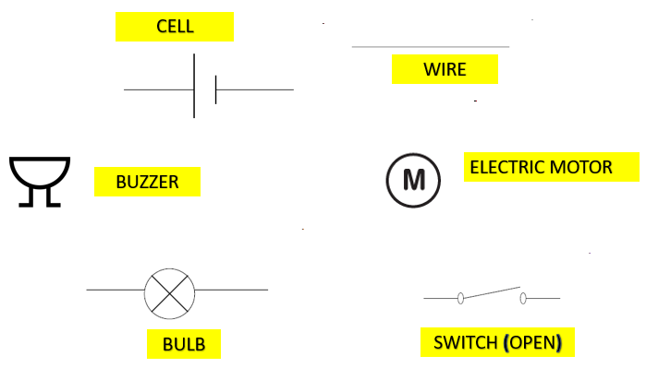
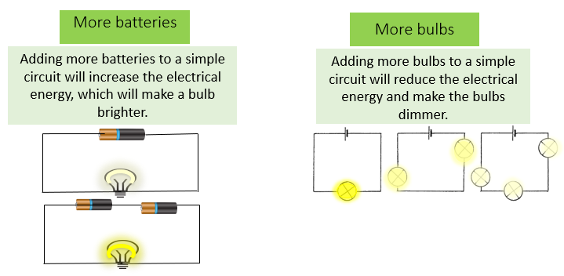
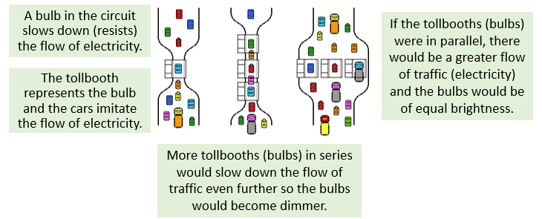
This diagram of a flow of traffic through a tollbooth can help explain the effect bulbs have in different types of circuit.

