
Cyberbullying, Digital Drama & Hate Speech
Theme of the half term:
Online Safety Newsletter

Summer 1 2024

How can I protect my child from cyberbullying?
Have clear rules about interacting online.
Talk about which private information should not be shared. This includes full name, date of birth, gender, home address. School name and any family members’ names.
Set limits and supervise online activities closely, while still supporting your child as they become more independent.
Choose high-quality, age-appropriate entertainment.
Explain to your child what cyberbullying is
Practice respectful communication and boundaries.
If they think they’re being bullied, make sure they are confident to talk to a trusted adult.
This half term the children will be learning about cyberbullying, digital drama and hate speech. The lessons which they will take part in will support them in how to deal with relationships online.

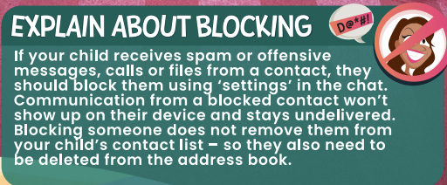
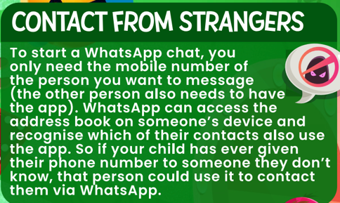
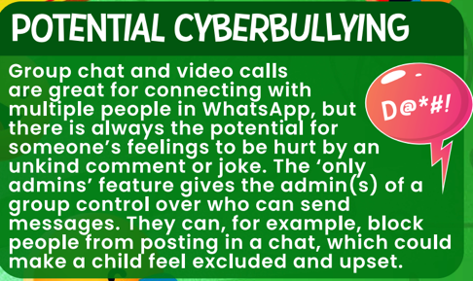

What is Cyberbullying?
This is a type of bullying which occurs on the internet via electronic devices. At SJA, we always say STOP (several times on purpose) to check if something we believe is bullying, really is.
This can include:
- Sending someone upsetting or threatening messages either through email, direct messages (DMs), group messages or text messages.
- Hacking into someone’s online account.
- Being rude or nasty to someone whilst playing games online.
- Posting private or embarrassing photos online or sending them to others.
- Creating fake social media accounts that mock someone or trick them.
- Excluding someone from an online conversation or blocking them for no reason.
For the full parents’ guide to WhatsApp please visit:
https://nationalonlinesafety.com/hub/view/guide/whatsapp-2022
WhatsApp Support for Parents

