Year 3/4
Summer 1: 2023/2024
Skegby Junior Academy – Knowledge Organiser

Why are rivers so important to cities?
Background Understanding
History:

Key Vocabulary
River | A large natural stream of water flowing in a channel to the sea, a lake, or another river.
Source | The headwaters of a river or stream is the farthest place in that river or stream from.
Meander | A winding curve in a river.
Mouth | A river mouth is where a river flows into a larger body of water, such as another river, a lake/reservoir, a bay/gulf, a sea, or an ocean.
Tributaries | A river or stream flowing into a larger river or lake.
Bank | The bank/side of a river.
Bed | The bed or channel in which a river flows.
Estuary | The tidal mouth of a large river, where the tide meets the stream.
Transportation | The action of transporting someone or something or the process of being transported.
Settlement | A place, typically one which has previously been uninhabited, where people establish a community.
English City | River
London | Thames
Nottingham | Trent
Liverpool | Mersey
Hull | Humber
Derby | Derwent
Gloucester | Servern
Leeds | Aire
Newcastle | Tyne
York | Ouse

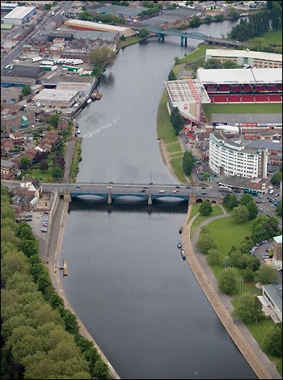
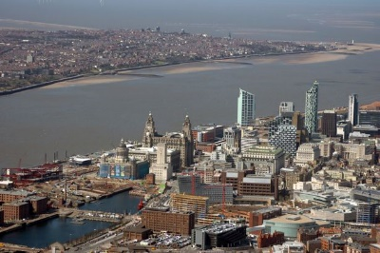
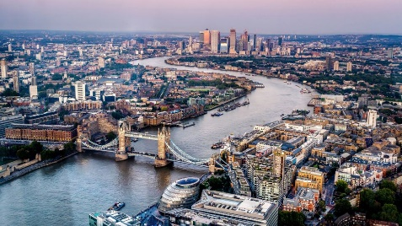

Spring 1: 2023/2024
Year 3/4
Skegby Junior Academy – Knowledge Organiser
Why were the Romans so powerful?
History:

Features of a River | Why do humans use rivers?
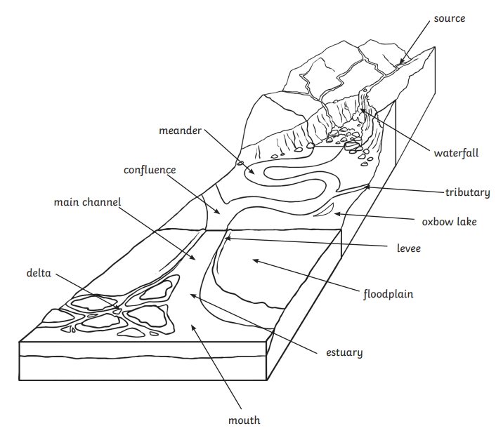 | Farming | River valleys and plains provide fertile soils. Farmers in dry regions irrigate their cropland using water carried by irrigation ditches from nearby rivers.
 | Energy | Rivers are an important energy source. During the early industrial era, mills, shops, and factories were built near fast-flowing rivers where water could be used to power machines. Today steep rivers are still used to power hydroelectric plants and their water turbines.
 | Transport | Rivers provide travel routes for exploration, commerce and recreation. In the industrial revolution, rivers were used to move goods and across the country.

