
Year 5 and 6
Background understanding for teachers and parents
Skegby Junior Academy – Knowledge Organiser
What is special about the USA?
Geography Topic:
Summer 1

Where in the world?
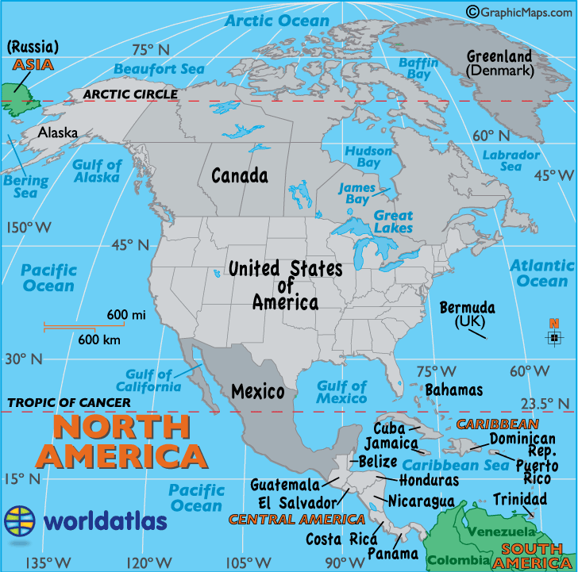
North America was the first populated about 10,000 years ago when people moved across the Bering Sea between Siberia and Alaska. First records are found on the island of Greenland from about 980. The European explorers arrived in larger numbers only after Christopher Columbus discovered America in 1492. Before the Europeans arrived in North America, the indigenous and native Americans were the people who lived on the continent.

North American Facts

North America is a continent. It is made up of 23 countries. Some of the largest of the countries are the United States of America, Mexico and Canada.

- North America has more than 590 million people living on the continent.
- The largest country in North America is Canada. It covers almost half of the continent’s land area. Canada is slightly bigger than the USA and about as big as China.
- Largest city: Mexico City, which is the capital city of Mexico. It has a population of more than 20 million inhabitants.
- Smallest country: St Kitts and Nevis with only 54,000 inhabitants.
- The longest river of North America is the Missouri River in the USA.
- The highest mountain is Denali in Alaska, USA.
- Biggest lake is Lake Superior. It is shared by Canada and the United States. It is as big as South Carolina or Austria! It is the largest freshwater lake in the world.
- The lowest point is Death Valley. It is in Death Valley National Park. It is 86m below sea level. It is the hottest and driest national park in the USA.
- There is no landlocked country in North America.

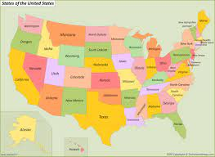
Key vocabulary
Key People

Climate | Weather conditions in an area.
Temperature | Degree or intensity of heat.
Precipitation | Rain, snow, sleet or hail that falls to the ground.
Deserts  (Death Valley) | A waterless, desolate area of land with little or no vegetation.
States | A nation considered as an organised political community under one government.
President | The elected head of a republic.
Governors | The person appointed in each state to be in charge.
Imperial measures | A system of measurement, measuring quantities such as length and mass.
Economy | How a region makes its money by the production or consumption of goods.
Characteristics | a feature or quality belonging typically to a person, place, or thing and serving to identify them.
Human features | Human features are things like houses, roads, and bridges. They have been built by people.
Physical features | Physical features like seas, mountains and rivers are natural.

Joe Biden – President of the United States of America | 
Kamala Harris – Vice President of the USA. | 
The Unites States of America is made up of 50 states. Each state is independently led by a Governor and their party. These are elected by the local people within that state.

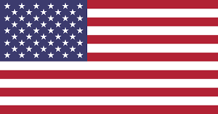
Facts about the USA

- The capital city is Washington DC (District of Colombia)
- The largest state is Alaska (which is the same size as Germany, Austria, Switzerland, France and Italy – COMBINED!) and the smallest state is Rhode Island.
- The largest city , with 8.4 million is New York City.
- California is the most populated state with 40 million inhabitants.
- The least populated is Wyoming with 580,000 people.

The United States of America’s flag is made up of 13 stripes, which refer to the 13 British colonies that declared independence from the Kingdom of Great Britain in 1776. The 50 stars refer to the 50 US states.

