
How can we rediscover the wonders of Ancient Egypt?
Year 5/6
History Topic:
Skegby Junior Academy – Knowledge Organiser

Spring 2
Background understanding for teachers and parents
Key vocabulary
Archaeologist | A person who researches and discovers artefacts.
Ancient | A synonym for old.
Pyramid | Ancient stone building with four sloping sides.
Pharoah | An Ancient Egyptian king or queen.
Hieroglyphics | A system of writing that used pictures and symbols instead of letters.
Tomb | A large vault typically where people are buried.
Hieroglyph | Ancient Egyptian writing.
Papyrus | a material used by the Egyptians that is similar to paper.
Artefact | An object that can tell us about the past.
Mummification | If a dead body is mummified, it is preserved, for example rubbing it with special oils and wrapping it in cloth.
Sarcophagus | A stone coffin.

For 3000 years, Ancient Egypt was home to some of the most influential inventions and discoveries in history. The Egyptians developed systems for writing (including hieroglyphics) and mathematics; they used paper and wrote texts on religion, astronomy and medicine. The Egyptians built magnificent buildings, temples and tombs, decorating them with pictures, paintings and carvings. The civilisation continued until the death of Cleopatra VII in 30BCE when Egypt fell to the Roman empire.

Where in the world?
Key people
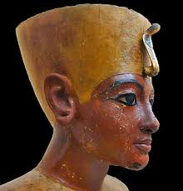 | Tutankhamun – the boy king – became Pharoah of Egypt in approximately 1333 BC. He reigned for 10 years. He died at a very young age.
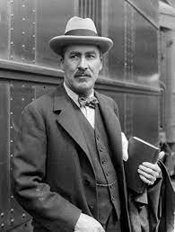 | Howard Carter – A British archaeologist and Egyptologist, who discovered the intact tomb of Tutankhamun in 1922.
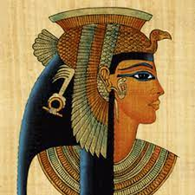 | Cleopatra VII – The final Pharoah queen of Egypt before the empire fell to the Romans in 31 BC.
 | He was known as the ‘boy king’ as he became Pharoah aged only 9. His tomb was discovered by Howard Carter and his team in the Valley of the Kings in 1922.
Egypt is on the continent of Africa. It is in the north-east of the continent and its north coast is on the Mediterranean Sea. Its east coast is also bordered by sea – the Red Sea.
Northern Egypt has wide valleys near the Nile and desert to the east and west. Southern Egypt’s landscape contains low mountains and desert.
Capital city: Cairo


