Year 3/4
Spring 2: 2024
Skegby Junior Academy – Knowledge Organiser

Why were the Norman Castles certainly not bouncy?
Background Understanding
History:

Key Vocabulary
Norman | A person who was mix of Scandinavian and Frankish who settled in Normandy.
Motte | An earth mound, forming a raised platform on which a tower could be built.
Bailey | The center of life within a castle.
Castle | A large building, typically of the medieval period, fortified against attack with thick walls, battlements, towers, and in many cases a moat.
Domesday Book | A manuscript record of the wealth and assets of the people in England and Wales in 1085.
Census | An official count or survey, especially of a population.
Seige | A military operation in which enemy forces surround a town or building, cutting off essential supplies, with the aim of compelling those inside to surrender.
Trebuchet | A kind of catapult that was used to hurl heavy stones or other projectiles during battles
Moat | A deep, wide ditch surrounding a castle, fort, or town, typically filled with water and intended as a defence against attack.
Barracks | A large building or group of buildings used to house soldiers.
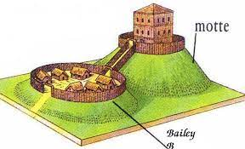
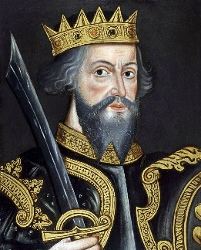
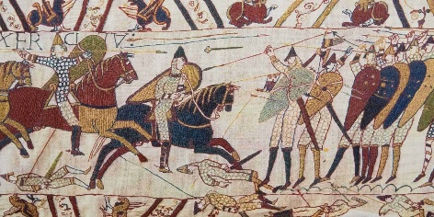

What is a Motte and Bailey Castle?
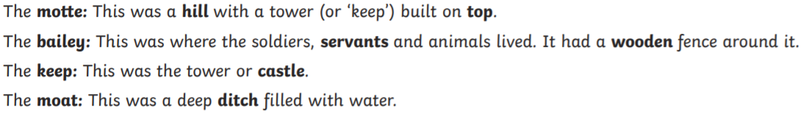

Who was William the Conqueror?
William I, by name William the Conqueror or (born. 1028, Falaise, Normandy, France — died September 9, 1087, Rouen), duke of Normandy (as William II) from 1035 and king of England (as William I) from 1066, one of the greatest soldiers and rulers of the Middle Ages. He made himself the mightiest noble in France and then changed the course of England’s history by his conquest of that country and won one of Britain’s most famous battles: The battle of Hastings.

Spring 1: 2021/2022
Year 3/4
Skegby Junior Academy – Knowledge Organiser
Why were the Norman Castles certainly not bouncy?
History:

A detailed diagram Motte and Bailey Castle


