Key Vocabulary | Definition
Rock | Natural substance, made up of one or more minerals.
Fossil | Trace or remains of an ancient living thing.
Igneous rock | Formed by the cooling and solidifying of molten materials.
Metamorphic rock | Rock that was once one form of rock but has changed to another under the influence of heat and pressure.
Sedimentary rock | Formed through the depositing and solidifying of sediment.
Geologist | A geologist studies the materials, processes, products, physical nature and history of the earth.

Skegby Junior Academy Knowledge Organiser Year 3 and 4 Spring 2
There are 3 main types of rock:


Igneous
rock
Sedimentary
rock
Metamorphic
rock
Pumice
Granite
Obsidian
Sandstone
Limestone
Marble
Slate
Larger crystals that interlock.
Marble

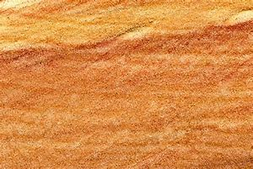
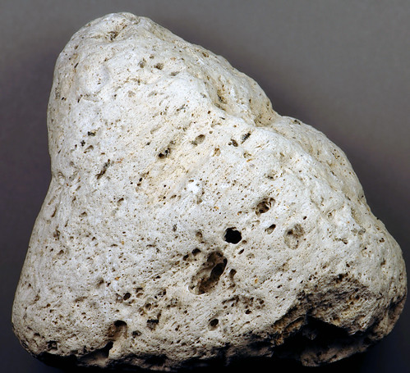

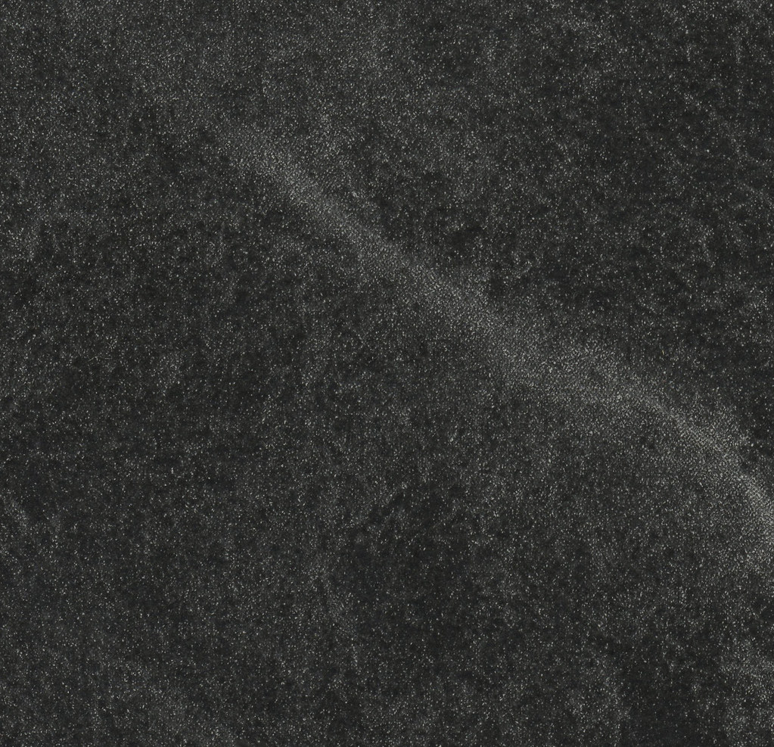
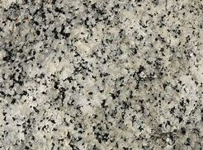
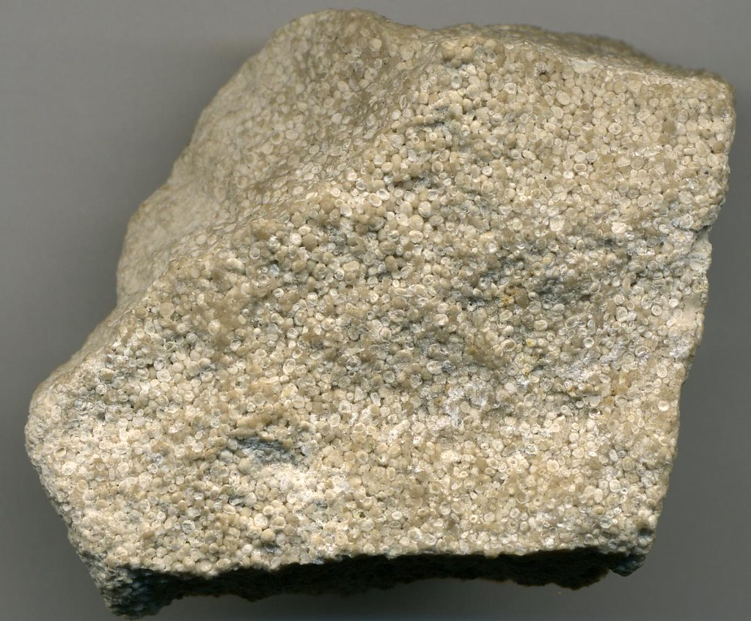

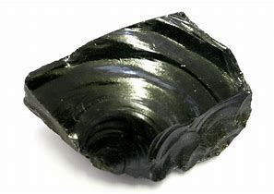
Mantle

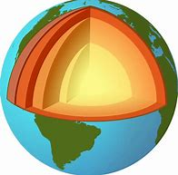
Crust
The Earth
has 3 layers!

Minerals are made of elements.
Elements are simple substances that cannot be broken down into any other substance.

Core
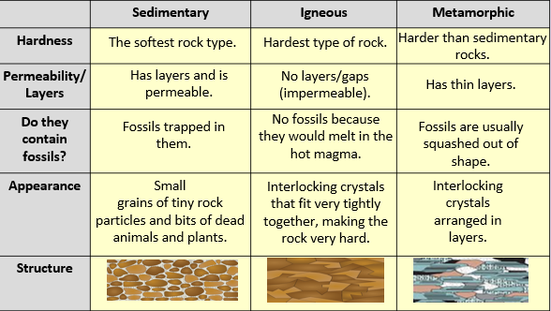
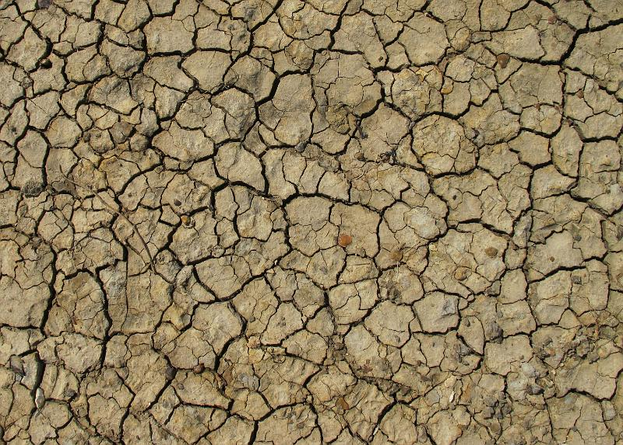
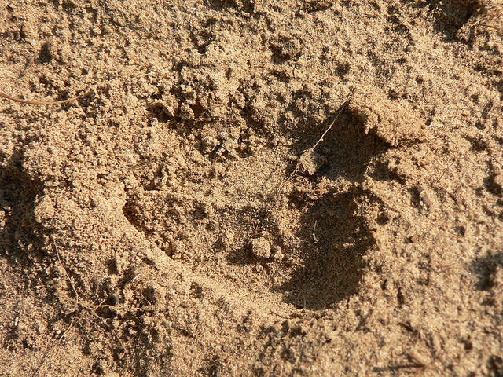
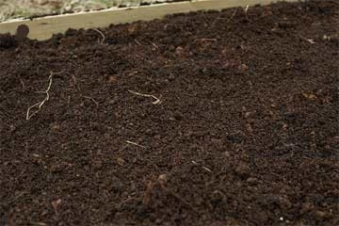
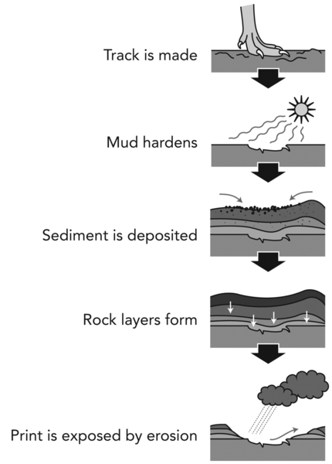
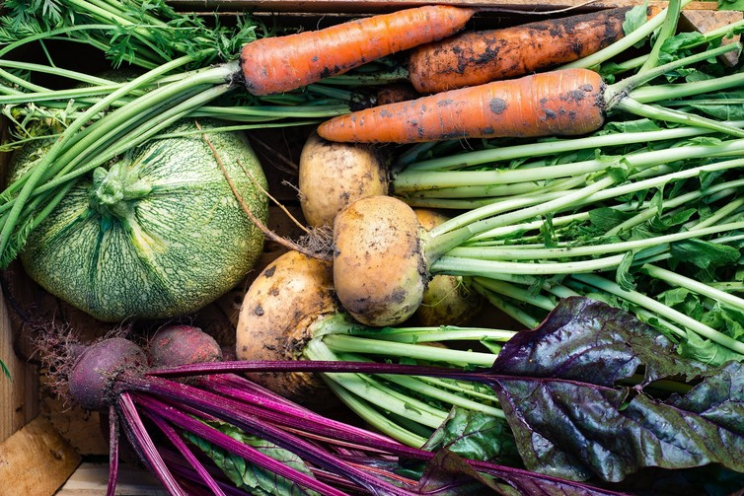
Loam soils are composed of a mixture of clay, sand and silt.
Clay
Silt
Sand
There are three main types of soil:
When a rock doesn’t let water through it, the rock is said to be impermeable.
When a rock lets water through, the rock is said to be permeable.
Fossil formation
Vitamins and minerals

