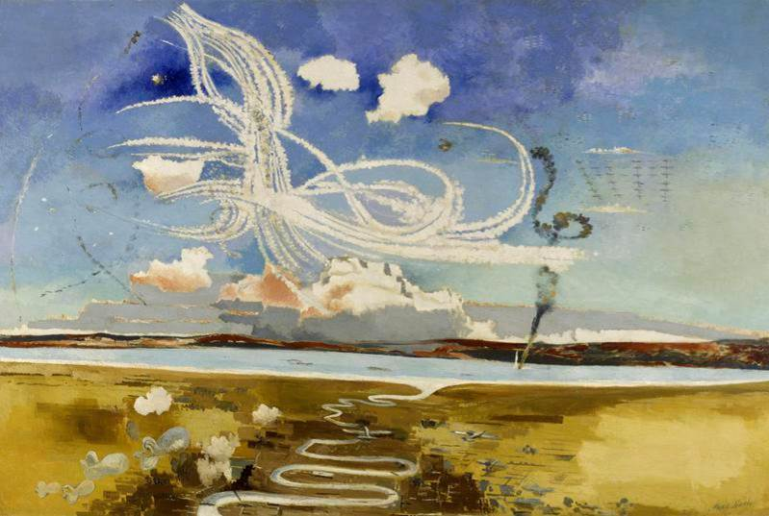
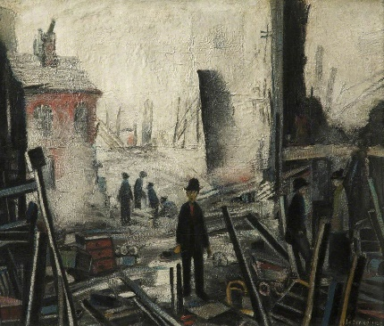

Treaties | Formal agreement between countries.
Blitz | Name of the bombing raids that Germany launched on Britain in 1940.
Kindertransport | The movement of Jewish children from Nazi Europe to safety.
Ally/Allies | A country who joins together with another country to fight together.
Bias | Prejudice for or against something.
Evacuation | Children leaving their families and homes to protect themselves against the bombings in the cities
Propaganda | Information designed to mislead or promote an idea.
Rationing | Limiting the amount of food that people get.
Evacuees | Children evacuated from cities.
Refugees | A person who had to leave their country to escape war.

Key vocabulary
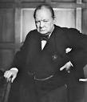 | Winston Churchill – The British Prime minister from 1940 and throughout the war.
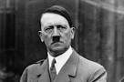 | Adolf Hitler – Leader of the National socialist party (Nazis) in Germany
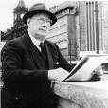 | L.S Lowry – A famous British artist famous for his stick men like paintings
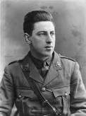 | Paul Nash – A famous British artist who was a paid war artist during WWII

Key people from the time
Year 5/6
Timeline of key events
1939 | 1st September – Germany invades Poland
1939 | 3rd September - The UK and France declare war on Germany
1940 | 10th May – Winston Churchill becomes Prime Minister – taking over from Neville Chamberlain
1940 | 26th May – 4th June – Evacuation of British and French troops from Dunkirk, France
1940 | June – German troops occupied the Channel Islands
1940 | 10th June – Italy declares war on Britain and France and becomes allies with Germany
1940 | 10th July – 31st October – Battle of Britain
1940 | 7th September – Blitz begins in London
1941 | 7th December – Pearl Harbour
1944 | 6th June – D-Day – British and American troops landed in France to fight the Germans
1945 | 8th May – Victory in Europe day – German surrenders
1945 | 15th August – Victory in Japan Day – Japan surrenders

World War 2 started in 1939 and lasted until 1945. It started as a result of German troops invading Poland on the 1st September 1939. The U.K declared war on Germany 2 days later. Many countries were involved and took sides – Italy and Japan joined Germany whilst the USA, France and the Soviet Union (Russia) joined with the UK. The war officially ended in Europe on the 8th May 1945 – known as V.E day (victory in Europe day).
Background understanding for teachers and parents
History Topic:
How could Hitler have convinced a nation like Germany to follow him?
Spring 1
Skegby Junior Academy – Knowledge Organiser

