Key Vocabulary | Definition
Force | A push or a pull.
Contact force | A force where objects need to touch each other to push or pull.
Non-contact force | A force where objects do not have to touch each other to push or pull.
Magnet | A material that produces a magnetic field.
Attract | To pull together.
Repel | To push away.
Magnetic pole | Where the magnetic field is strongest.
Examples of contact force
Friction is the force which acts in the direction opposite to the motion.

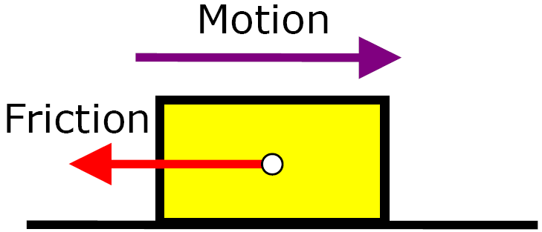
Applied force (push)
Tension (pull)
Friction

Air resistance
Friction always slows a moving object down.
Friction always slows a moving object down.

Water resistance
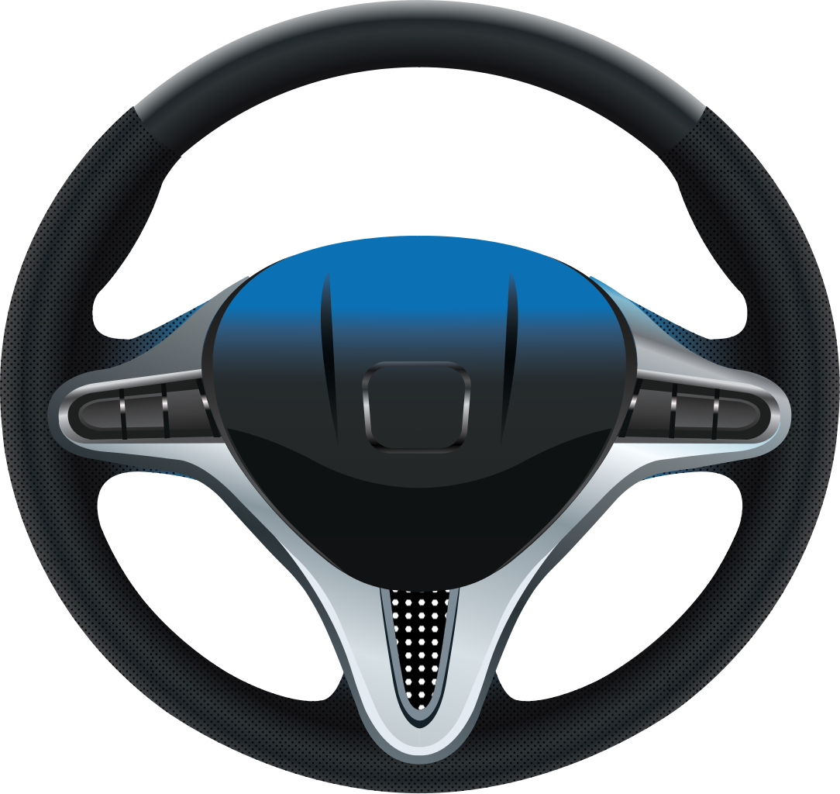
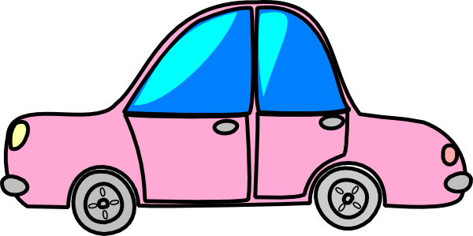
Spring force (twist)
Examples of non-contact force

Gravity
Less force is needed to move the car on smooth surfaces (it is easier to move).
The force needed to move the car is greater on rough surfaces (so it is harder to move).
Magnetic force

Static Electricity
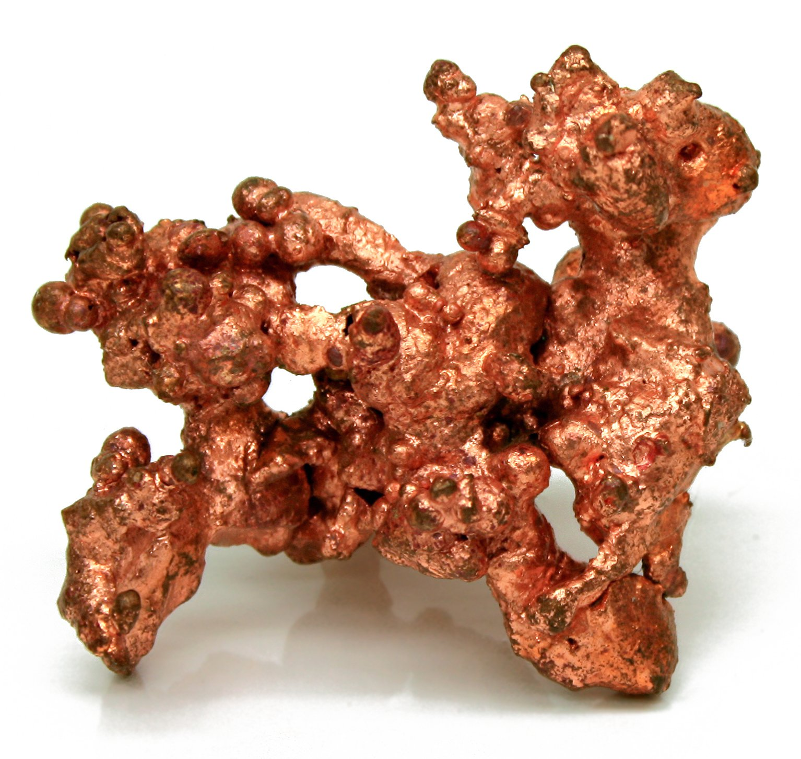
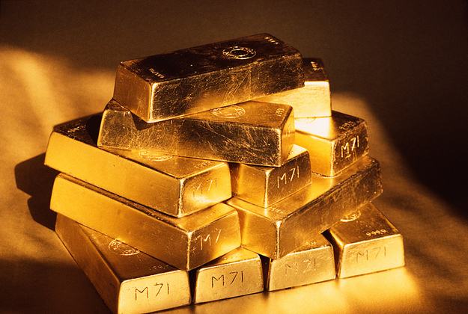
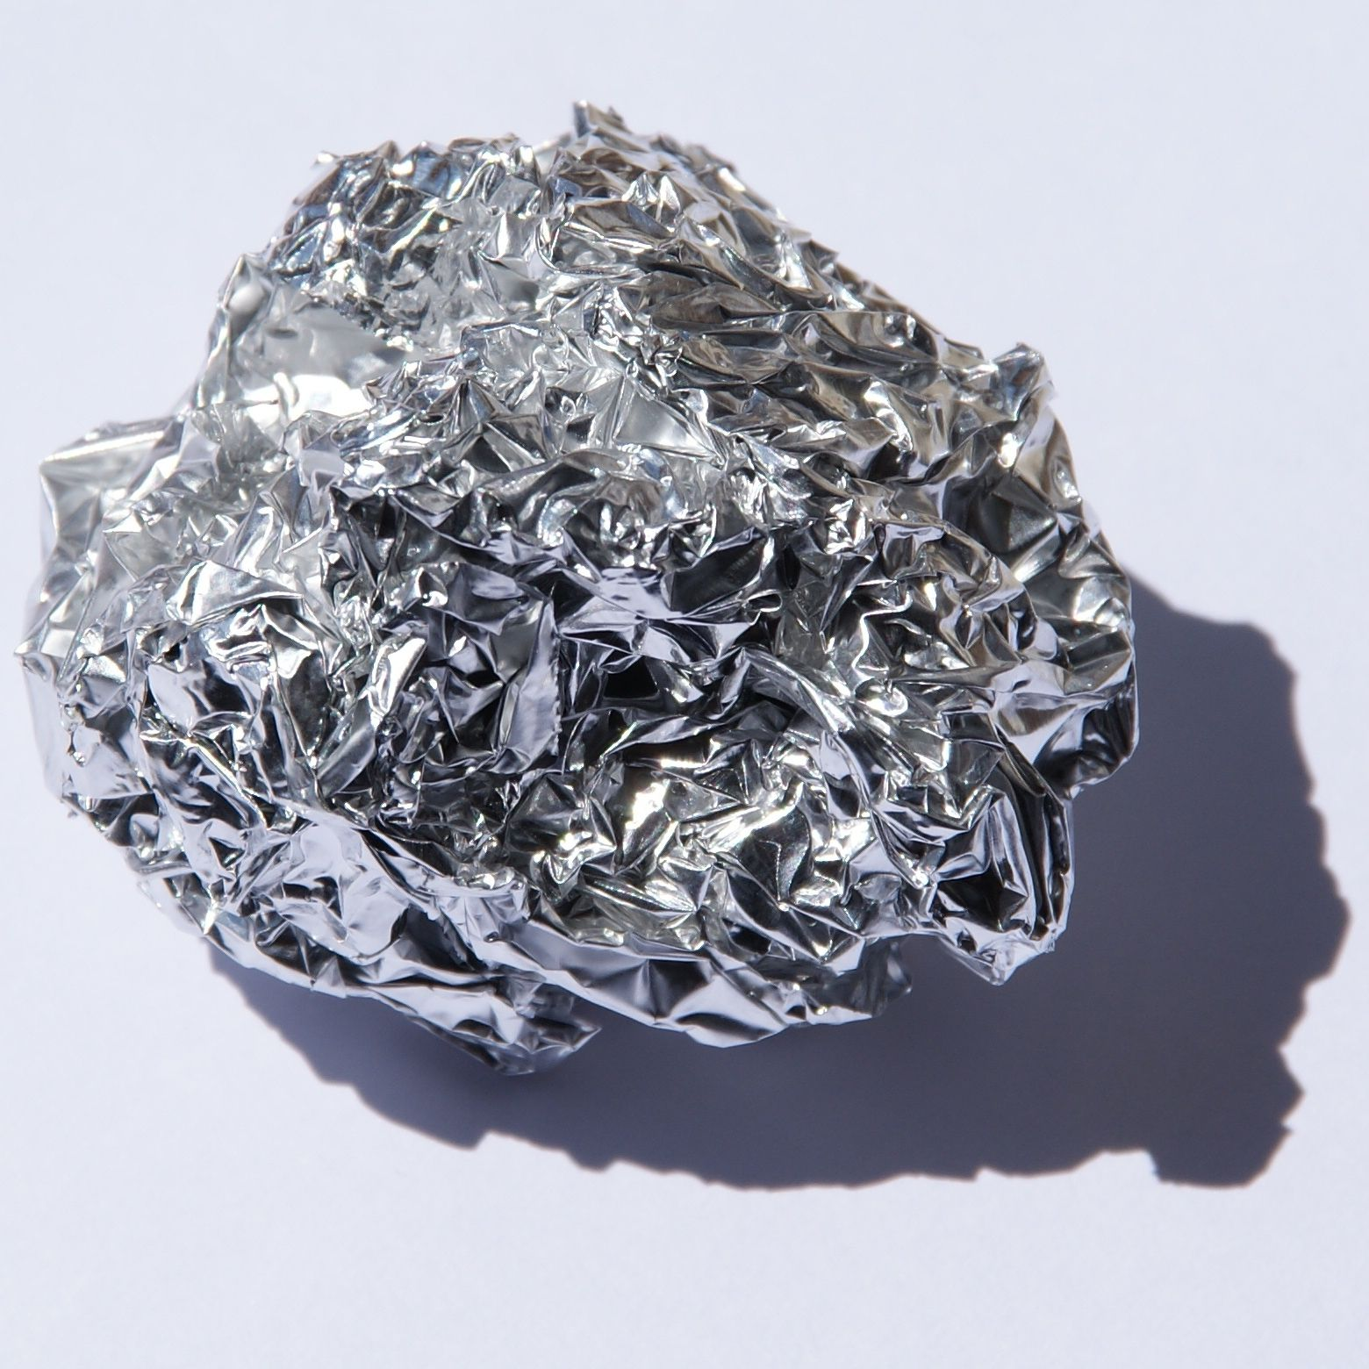
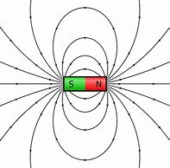
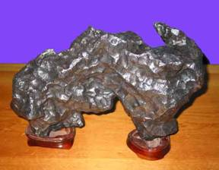
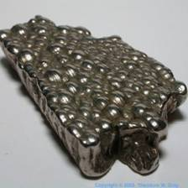
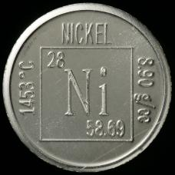
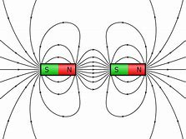
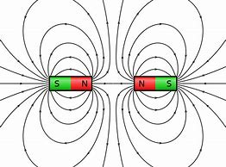

Gold
Steel contains iron so it will be magnetic.
Non-magnetic materials
Copper
Iron
Cobalt
Magnets produce an area of magnetic force called a magnetic field.
south pole
magnetic field
north
pole
Aluminium
Nickel
Magnetic materials
If a north pole is next to the south pole, then the field lines go straight from the north pole to the south pole.
Attract
If north poles or south poles face each other, field lines move away from each other.
Repel
Vitamins and minerals

