8
Year 3/4
Spring 1 2024
Skegby Junior Academy – Knowledge Organiser

Why were the Romans so powerful?
Background Understanding
History:

Key Vocabulary
Roman Empire | An extensive group of states or countries ruled over by a single state.
Ancient | Belonging to the very distant past and no longer in existence.
Boudicca | A queen of the British Iceni tribe who led an uprising against the Roman Empire in AD 60.
Juilus Ceasar | A Roman general and emperor.
Invasion | An instance of invading a country or region with an armed force.
Settler | A person who moves with a group of others to live in a new country or area.
Gladiator | A man trained to fight with weapons against other men or wild animals in an arena.
Century | 100 years.
Decade | 10 years.
Emperor | A sovereign ruler of an empire


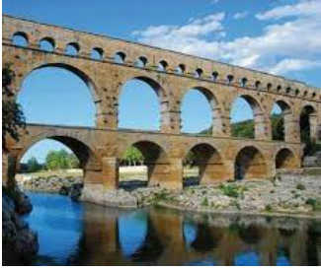
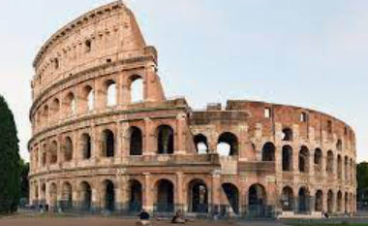

Roman Inventions | Roman Numerals
Roads and highways | I = 1
Calendars | II = 2
Aqueducts | III = 3
Underfloor heating | V = 5
Books | X = 10
Newspapers | L = 50
Sewers | C = 100
Roman Baths | D = 500
Surgical Tools | M = 1,000

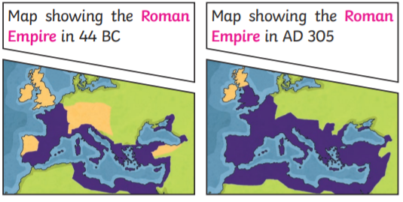

Spring 1: 2021/2022
Year 3/4
Skegby Junior Academy – Knowledge Organiser
Why were the Romans so powerful?
History:

A Timeline of Roman Britain

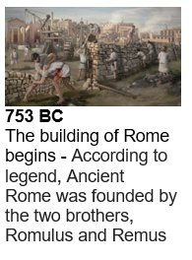 | 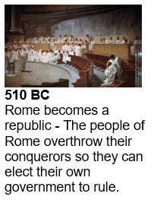 | 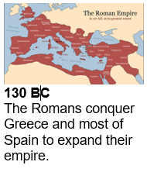 | 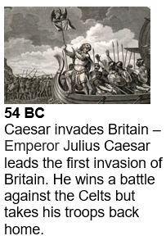 | 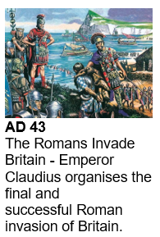
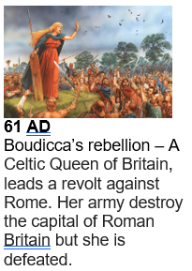 | 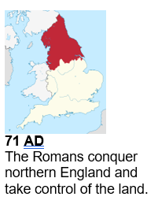 | 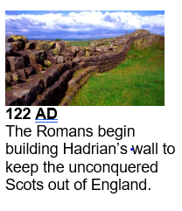 | 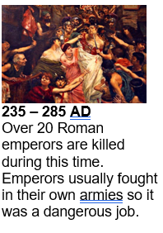 | 

