
Privacy & Security
Theme of the half term:
Online Safety Newsletter

Autumn 2 2023

How can I help my child with safer passwords?
To help your children with safer passwords they need to have the following things:
- needs to be a word, phrase, or a sentence.
- It needs to be long with capital letters, small letters, numbers, and special characters like !@#$%
- It needs to be easy for the child to remember but not easy for others to guess!

This half term the children will be learning about how to keep themselves safe online through understanding what is safe to share and what is not.

What is tracking?
If you are using a mobile device, it has very accurate information about your location, some apps need to know your location to be able to work e.g. google maps.
The main reason apps track your location is because it makes money! Your information is sold to marketers, making it easier to show you adverts you should be interested in.
How can I turn off tracking?
If you have an Apple device, follow these steps:
Open “Settings.”
Tap “Privacy” and click on “Location Services.”
Next, tap the app you want to change the location setting for.
Then, select the option you want, like “Always,” “While using,” or “Never.”
To change the location setting for apps on an Android phone:
Tap on “Settings.”
Then, tap on “Apps & Notifications.”
Pick an app and tap on “Permissions.”
Switch “Location” to on or off.
To read more about this visit mcafee.com
and Trend Micro


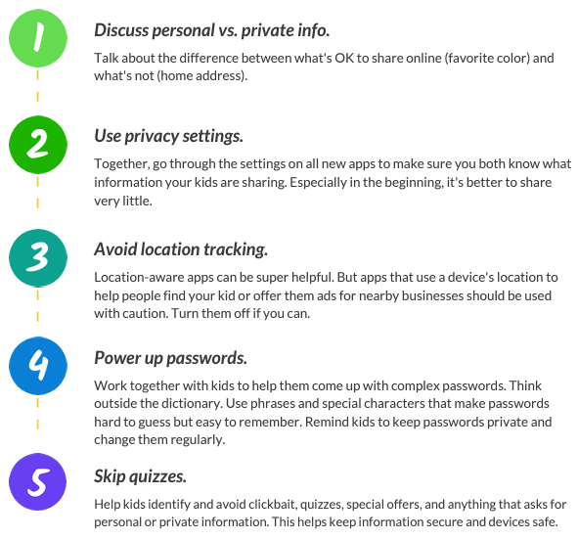
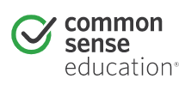
Privacy and Security support for Parents
Examples of strong passwords: 

