
Digital Footprint & Identity
Theme of the half term:
Online Safety Newsletter

Spring 1 2024

Some of our children are at the age where they are starting to share content and engage with others online, it's important for them to understand the tracks they're leaving behind and what those tracks might reveal. Parents can help guide kids toward creating the kind of footprint they can be proud of. This includes what kind of images they post to what things they share. Many employers (although something our children will not be thinking about yet!) look at social media to screen candidates. This means they look at status’, posts, photos etc. Would you be open and willing to show an employer your social media?
This half term the children will be learning about their digital footprint and how to keep their identity safe online.

What is our digital footprint?
Here are 7 things, according to childline.org.uk that are counted as part of our digital footprint:
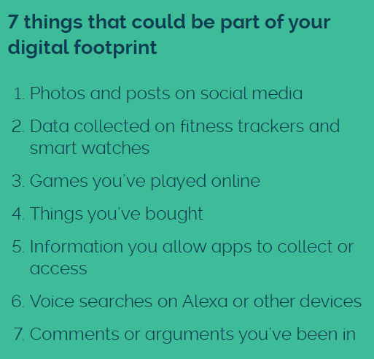
Click here to find more information on Childline.org
Privacy settings
Many apps will set its privacy settings to public automatically – To change Whatsapp settings to private, see below.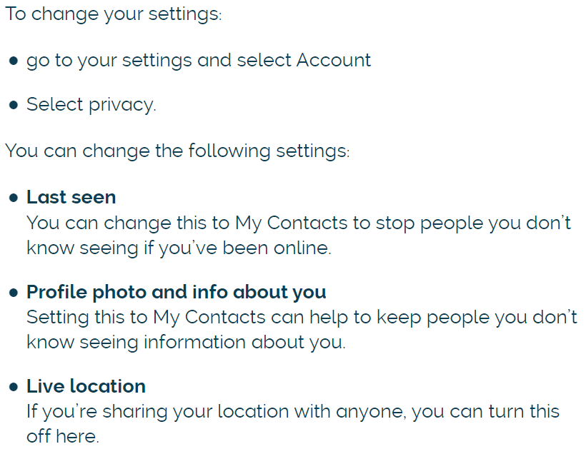

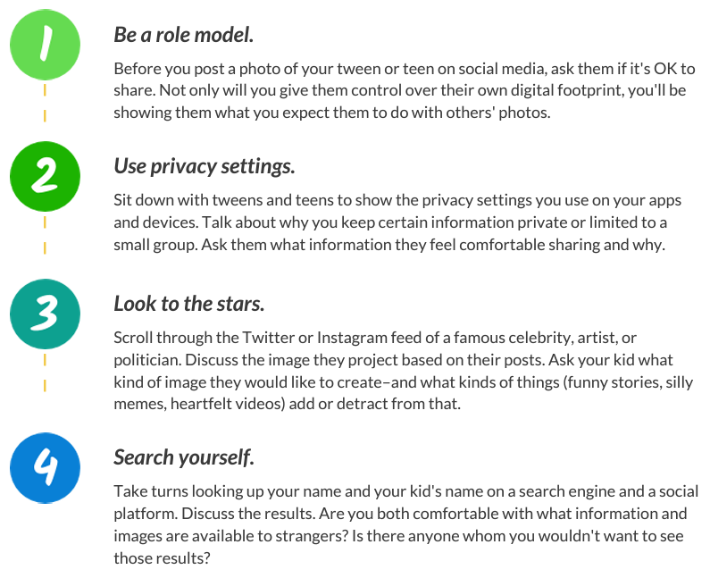

Please visit Childline where it has guides to many popular apps and how to change their privacy settings.
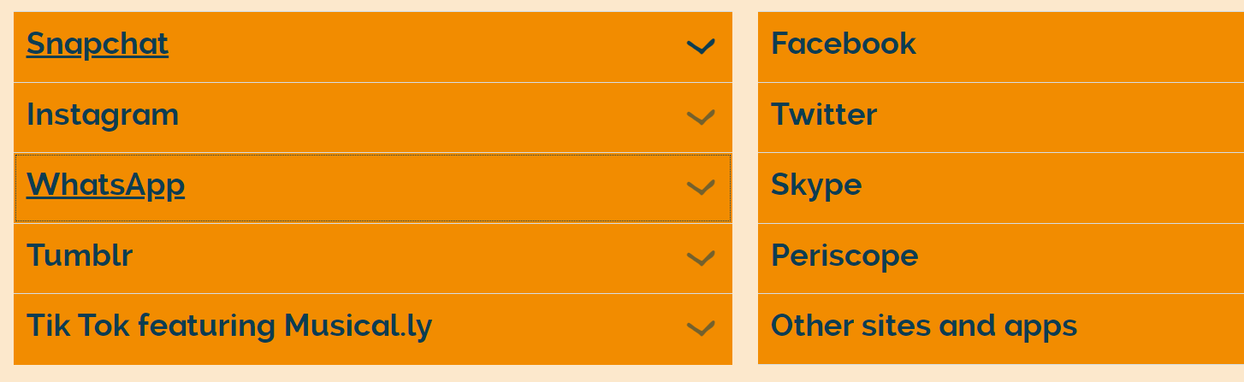
Examples of strong passwords:

Digital Footprint & Identity support for Parents

