8
Year 3/4
Autumn 2: 2023
Skegby Junior Academy – Knowledge Organiser

Background Understanding
Why is Nottinghamshire such a cool place to live?
Geography:
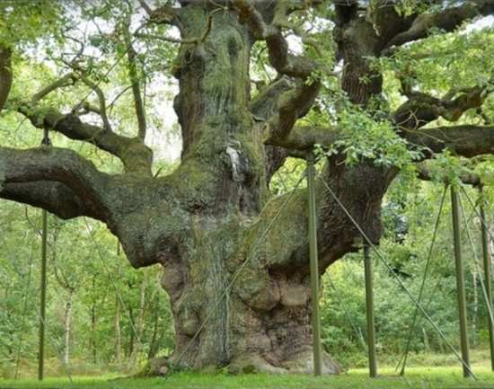
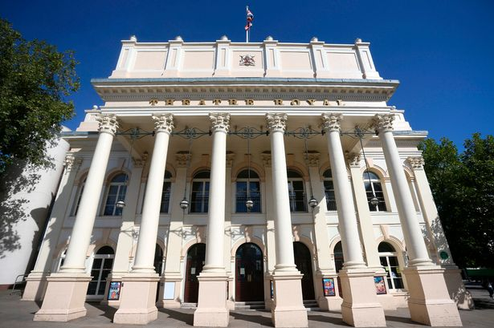
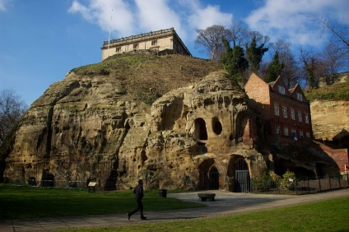
Timeline of Nottingham
868AD | Danes take the town
1067AD | Nottingham Castle is built
1232AD | St Mary’s hospital founded
1284AD | Nottingham Goose Fair begins
1330AD | Young King Edward III and a group of conspirators crept through a secret tunnel into the city's castle and took prisoner Roger de Mortimer, a nobleman who had until then effectively been England's ruler
1588AD | Wollaton Hall built
1642AD | Charles I raises royal standard at Castle Hill
1796AD | Nottingham Canal opens
1849AD | Boots the Chemist begins business
1890AD | Raleigh Cycles in business
1929AD | Nottingham Council House built

Vocabulary
village | Smaller than a town and situated in a rural area
town | A built up area with defined boundaries and a local government
city | A large town which usually has a cathedral and a university
county | A territorial division and unit of local government e.g. Nottinghamshire
population | The number of people that live in a particular place
attraction | A place which draws in visitors by providing something
location | A particular place
monument | A statue or building to remember something or someone
castle | A large building which is fortified against attack
Sherwood Forest | A royal forest in Nottinghamshire, England

Autumn 2: 2023
Year 3/4
Skegby Junior Academy – Knowledge Organiser
Background Understanding
Why is Nottinghamshire such a cool place to live?
History:

Places of Interest in Nottinghamshire
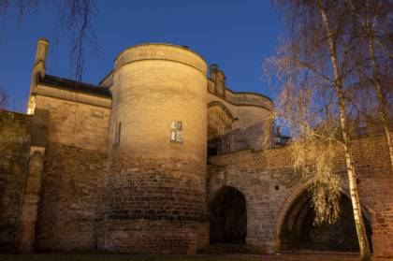  Nottingham Castle |   Motorpoint Arena
  Wheelgate Theme Park | 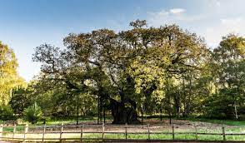  Sherwood Forest
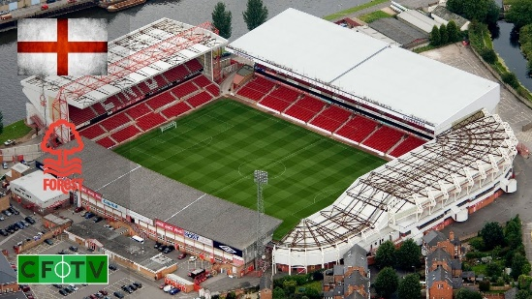  Nottingham Forest (City Ground) |   Goose Fair
The Story of Robin Hood
Deep in the heart of Sherwood Forest, among the ancient oaks, the King’s road between London and York would be raided by outlaws. The rich were forced to surrender all they had, while the common folk went free. Those in need were clothed, fed, and housed. This band of outlaws, who robbed from the rich and gave to the poor, stood against the tyrannous yoke of unjust lords and sheriffs. The leader of these fighters for social justice? Robin Hood.


