Key Vocabulary | Definition
Balanced diet | A diet that means you get the right types and amounts of foods and drinks to keep you healthy.
Nutrients | A substance that provides nourishment essential for the maintenance of life and for growth.
Skeleton | The hard structure that supports the body of a living thing.
Muscles | Move different parts of the body, inside and out.
Joints | Hold two bones together and allow movement.
Vertebrate | An animal that has a backbone or spinal column, including mammals, birds, reptiles, amphibians, and fishes.
Invertebrate | An animal lacking a backbone, such as an arthropod, mollusc, annelid, coelenterate,
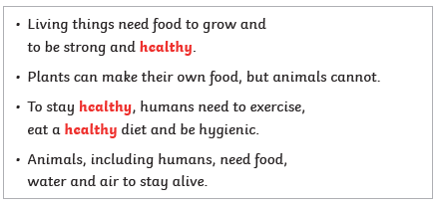
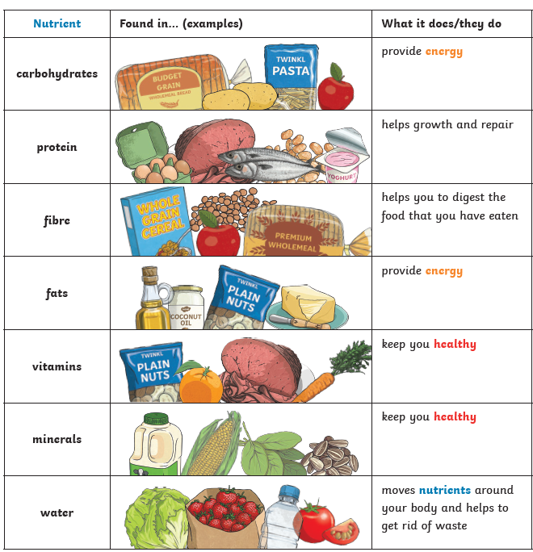


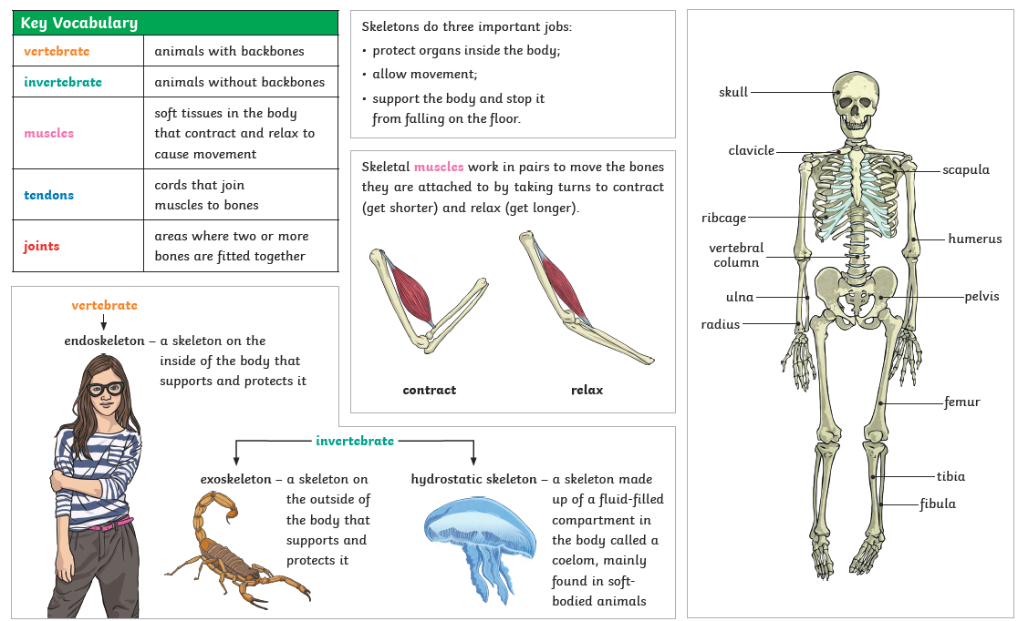
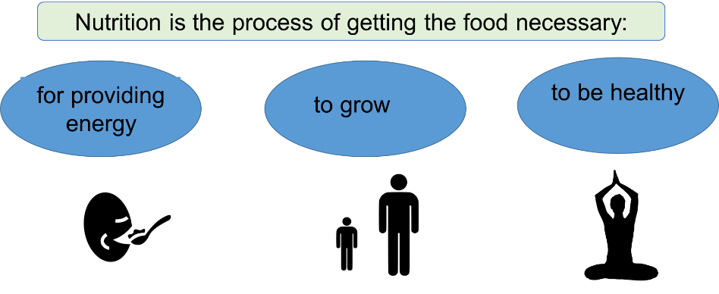
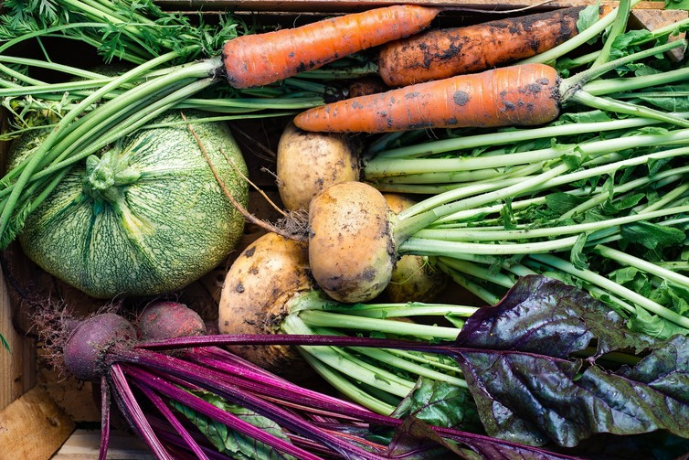
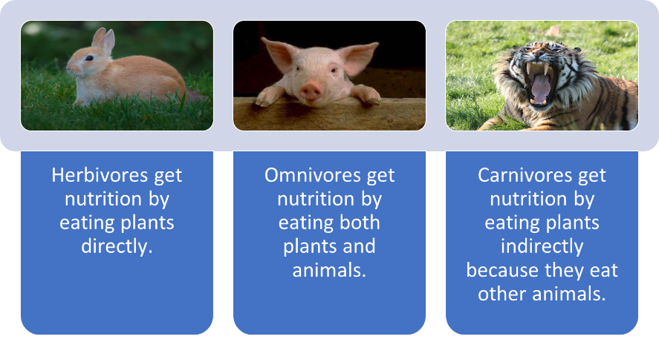
Vitamins and minerals

