
How can materials change?
Science Topic:
Skegby Junior Academy – Knowledge Organiser
Key Vocabulary | Definition
Electrical conductivity | Ability to conduct or transmit electricity.
Solubility | How well a substance dissolves.
Thermal conductivity | Ability to conduct or transmit heat.
Dissolve | To mix with a liquid and become part of the liquid.
Insoluble | Something that is not able to dissolve.
Filtering | Process to use when you can separate small objects.
Insulator | Stops electricity or heat being transmitted.
Examples of reversible changes that can change back to their original form.
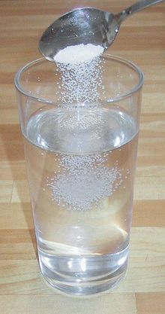

Larger crystals that interlock.
Marble
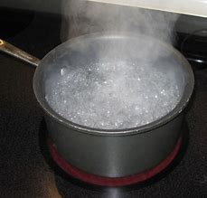
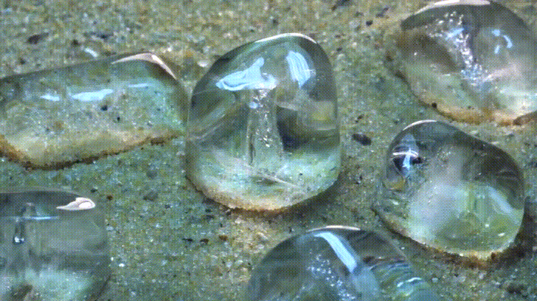
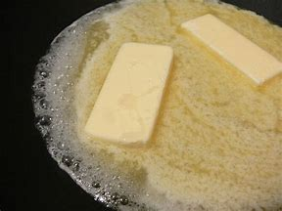

Melting butter
Boiling water
Ice cubes melting

Solution of sugar and water
When a solid (solute) dissolves in the liquid (solvent), a solution is formed.


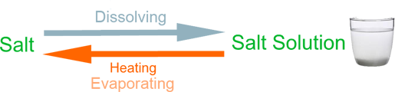



Most metals are good conductors of heat.
Some materials allow electric current to flow more freely than others e.g. metals. These materials are called electrical conductors.

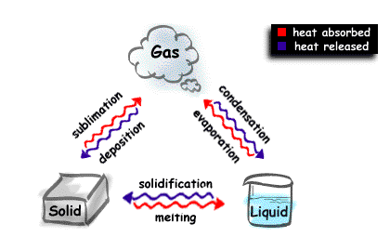
evaporating
sieving
filtering
Mixing materials together forms a mixture where two or more substances are physically combined. It can be separated by physical methods such as:
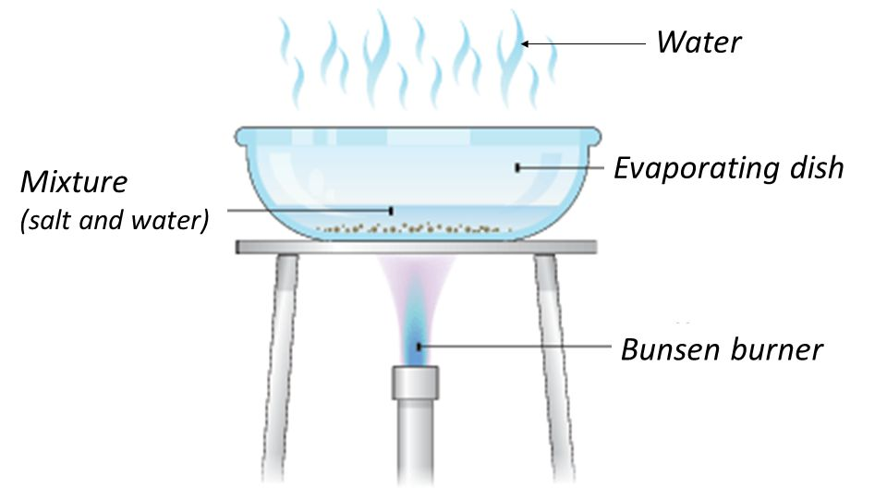
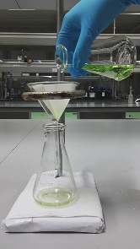
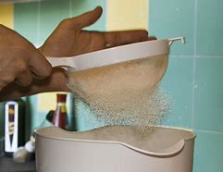

Examples of chemical changes are:
cooking and baking
Chemical changes produce new substances.
Evidence of a chemical reaction can be identified through:
Change of colour
Change of smell
Change of composition
The change cannot be reversed
State changes are reversible.
fermentation
rusting
burning
Separating soluble solids from liquids.
Separating different solids.
Separating insoluble solids from liquids.

