
Skegby Junior Academy – Knowledge Organiser
Geography Topic:
Year 5 and 6 Autumn 1
Will you ever see the water that you drink again?

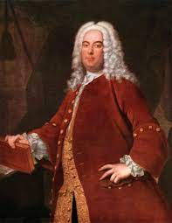
George Frideric Handel
In the summer of 1717, Handel premiered one of his greatest works, Water Music, in a concert on the River Thames. The concert was performed by 50 musicians playing from a barge positioned closely to the royal
barge from which the King listened. It was said that King George enjoyed it so much that he requested the musicians to play the suite three times during the trip!
Human Features | Human characteristics/impact that shapes a place (language, politics, buildings)
Physical Features | Physical features are natural aspects that shape a place (soil, climate, landforms)
Climate | Climate is the average weather in a given area over a longer period of time
Commodity | Basic goods and materials that are widely used
Water vapour | Any rain, snow, sleet or hail that falls to earth.
Evaporation | The process of a liquid becoming a gas
Condensation | The process when water vapour in the air changes from a gas back into a liquid
Reservoir | A large natural or artificial lake used as a source of water supply
Continent | A large continuous mass of land. There are seven continents.
Country | An area of land that is controlled by its own government.
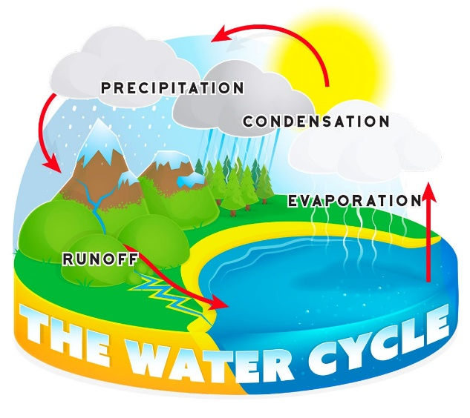

Percussion - musical instruments played by striking with the hand or with a stick or beater, or by shaking.

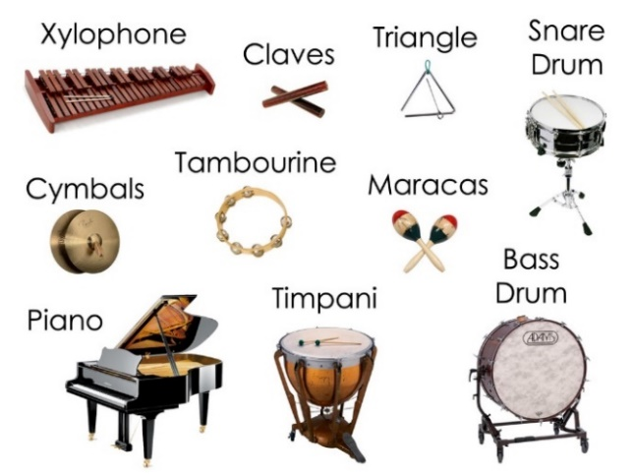
Sources of water



