
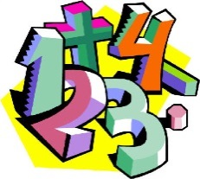

Skegby Junior Academy’s Written Calculation Policy for Mathematics
This policy was last reviewed and agreed in March 2021.
We have written this policy to reflect the new curriculum (September 2014) which demonstrates the best methods for each of the 4 operations that we think will most suit the needs of our children. Moving a child on through the calculation steps should generally be done within age related expectations and readiness. However where this is inappropriate, for SEN or G&T needs, a child should be moved on at their pace. Best practise would suggest that you give children the opportunity to try the next step for themselves as sometimes this step may suit their learning and thinking style better than where they ‘should be’. The intention is to support each child to move towards Standard Written Methods (as set out in this policy) as soon as they are ready rather than when in a specific year group. Written methods encourage children to think about the mental strategies that underpin them and to develop new ideas. Therefore written recording both helps children to clarify their thinking and supports and extends their understanding of mental strategies.
To ensure continuity, the ways in which we set out work are also contained within this policy.
- In Numeracy books each digit should be written in an individual box.
- The children will always work in pencil in their Numeracy books.
- Children will be encouraged to show methods of working out / jottings.
- Mental estimates of answers will be encouraged to accompany the written methods.
- Decimal points should always be written in a box of their own.
- The terms hundreds (H), tens (T) and units (U) will be used, tenths (tth) and hundredths (hth) for decimals.
- Multiplications will be written as in the tables (1x2=2, 5x4=20) and spoken using a range of language eg. 3 times 4 (meaning 3 lots of 4).

The language taught for each operation should reflect the full range of age related language for each unit, progressing throughout school. Children will always be encouraged to look at a calculation/problem and then decide which is the best method to use; pictures, mental calculation with or without jottings, structured recordings or a calculator. Inverse calculations (+/- and x/÷) are to be used by children where they are secure in the original method and/or are using RUCSAC for problem solving. (RUCESAC for Y5/6)

Children in Years 1 and 2 will be given a really solid foundation in the basic building blocks of mental and written arithmetic. Through being taught place value, children will develop an understanding of how numbers work, so that they are confident with 2-digit numbers and beginning to read and say numbers above 100.

Addition and Subtraction: A focus on number bonds, first via practical hands-on experiences and subsequently using memorisation techniques, enables a good grounding in these crucial facts, and ensures that all children leave Year 2 knowing the pairs of numbers which make all the numbers up to 10 at least. Children will also have experienced and been taught pairs to 20. Children’s knowledge of number facts enables them to add several 1-digit numbers, and to add/subtract a 1-digit number to/from a 2-digit number.Another important conceptual tool is the ability to add/subtract 1 or 10, and to understand which digit changes and why. This understanding is extended to enable children to add and subtract multiples of 10 to and from any 2-digit number. The most important application of this knowledge is the ability to add or subtract any pair of 2-digit numbers by counting on or back in 10s and 1s. Children may extend this to adding by partitioning numbers into 10s and 1s. | Multiplication and Division: Children will be taught to count in 2s, 3s, 5s and 10s, and will relate this skill to repeated addition. Children will meet and begin to learn the associated ×2, ×3, ×5 and ×10 tables. Engaging in a practical way with the concept of repeated addition and the use of arrays enables children to develop a preliminary understanding of multiplication, and asking them to consider how many groups of a given number make a total will introduce them to the idea of division. Children will also be taught to double and halve numbers, and will thus experience scaling up or down as a further aspect of multiplication and division. | Fractions: Fractions will be introduced as numbers and as operators, specifically in relation to halves, quarters and thirds.

Coverage in Key Stage One:

Coverage in Lower Key Stage Two:
In Lower Key Stage 2, children build on the concrete and conceptual understandings they have gained in Key Stage 1 to develop a real mathematical understanding of the four operations, in particular developing arithmetical competence in relation to larger numbers.

Addition and subtraction: Children are taught to use place value and number facts to add and subtract numbers mentally and they will develop a range of strategies to enable them to discard the ‘counting in 1s’ or fingers-based methods of Key Stage 1. In particular, children will learn to add and subtract multiples and near multiples of 10, 100 and 1000, and will become fluent in complementary addition as an accurate means of achieving fast and accurate answers to 3-digit subtractions. Standard written methods for adding larger numbers are taught, learned and consolidated, and written column subtraction is also introduced. | Multiplication and division: This key stage is also the period during which all the multiplication and division facts are thoroughly memorised, including all facts up to 12 × 12. Efficient written methods for multiplying or dividing a 2-digit or 3-digit number by a 1-digit number are taught, as are mental strategies for multiplication or division with large but ‘friendly’ numbers, e.g. when dividing by 5 or multiplying by 20. | Fractions and decimals: Children will develop their understanding of fractions, learning to reduce a fraction to its simplest form, as well as finding non-unit fractions of amounts and quantities. The concept of a decimal number is introduced and children consolidate a firm understanding of 1-place decimals, multiplying and dividing whole numbers by 10 and 100.

Coverage in Upper Key Stage Two:
In Lower Key Stage 2, children build on the concrete and conceptual understandings they have gained in Key Stage 1 to develop a real mathematical understanding of the four operations, in particular developing arithmetical competence in relation to larger numbers.
Addition and subtraction: Children are taught to use place value and number facts to add and subtract numbers mentally and they will develop a range of strategies to enable them to discard the ‘counting in 1s’ or fingers-based methods of Key Stage 1. In particular, children will learn to add and subtract multiples and near multiples of 10, 100 and 1000, and will become fluent in complementary addition as an accurate means of achieving fast and accurate answers to 3-digit subtractions. Standard written methods for adding larger numbers are taught, learned and consolidated, and written column subtraction is also introduced. | Multiplication and division: This key stage is also the period during which all the multiplication and division facts are thoroughly memorised, including all facts up to 12 × 12. Efficient written methods for multiplying or dividing a 2-digit or 3-digit number by a 1-digit number are taught, as are mental strategies for multiplication or division with large but ‘friendly’ numbers, e.g. when dividing by 5 or multiplying by 20. | Fractions and decimals: Children will develop their understanding of fractions, learning to reduce a fraction to its simplest form, as well as finding non-unit fractions of amounts and quantities. The concept of a decimal number is introduced and children consolidate a firm understanding of 1-place decimals, multiplying and dividing whole numbers by 10 and 100.

Addition
(The majority of children should be using the column method for addition before leaving Year 6).
Stage 1-various practical activities to ensure a conceptual understanding of what addition is. Children begin to record in the context of play or practical activities or problems.
Children will be learning how to count objects, match to the numeral, find and write the correct number next to them.
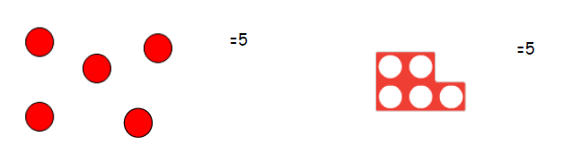
Children will then learn to combine and count two sets of objects (aggregation).
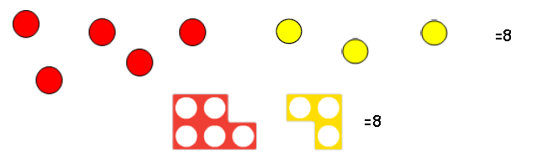
Next, children will learn to add on to an existing set (augmentation). This means that they will start from 5 and count 3 more to 8.
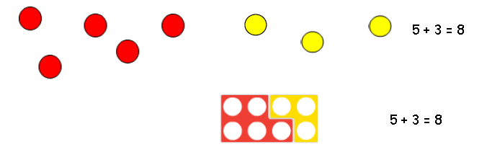
Augmentation is the first step towards a written calculation and children will be using the ‘+’ and ‘=’ symbols.

Stage 2-using numberline alongside practical resources.
When doing addition, encourage the children to put the higher number first.
Children use a number line to count on in ones. Children use number lines and practical resources to support calculation and teachers demonstrate the use of the number line.
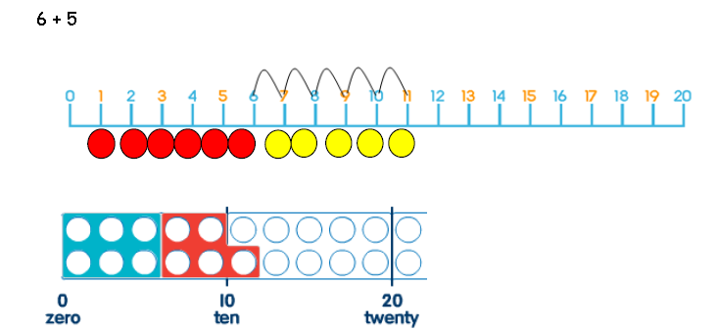
Children are encouraged to use their knowledge of number bonds to help them partition numbers.
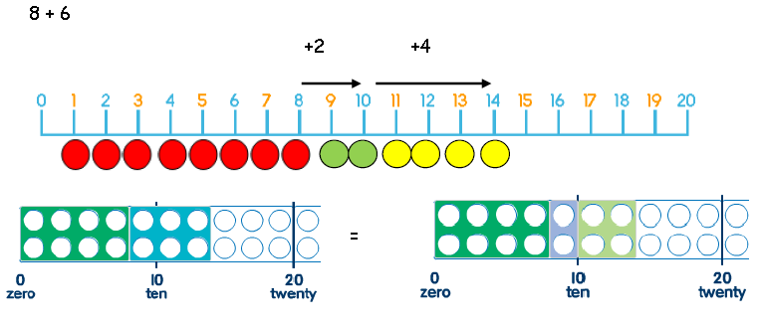

Children should be able to add 9 or 11 by adding 10 and adjusting by 1

Add 9 or 11 by adding 10 and adjusting by 1, for example:
35 + 9 = 44 +10
-1

Stage 3- using an empty number line alongside practical resources.
As children become more confident with numbers, they will begin to use an empty number line. They can now add in bigger jumps.
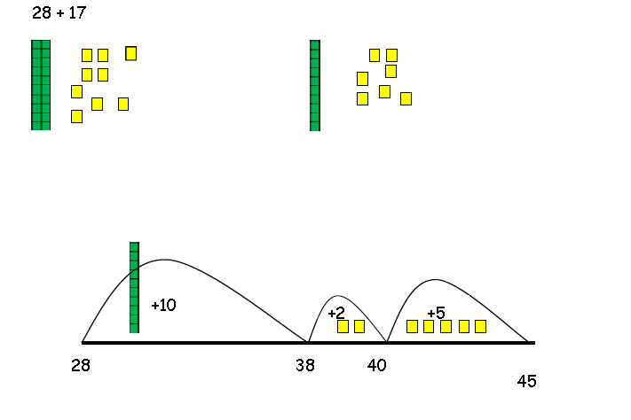
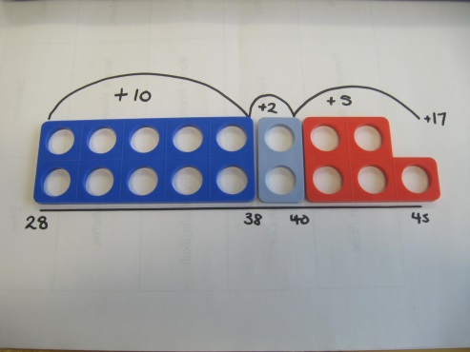
Counting on can also be modelled using a number square. Add 10s first and then units. (As we agreed this was easier for the children to do)
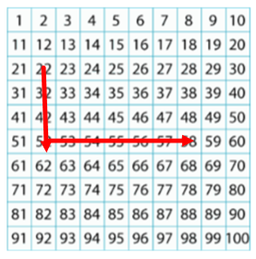
22 + 36 = 58

Stage 4- partitioning and recombining.
Children need to understand the two answers from T & U’s need to be added together in order to get the answer.
Children need to understand that a zero between digits is a place holder, e.g. 103.
59 + 22 =  50 + 20 = 70  9 + 2 = 11  70 + 11 =  70 + 10 = 80  0 + 1 = 1  So, 59 + 22 = 81. | Then move onto just partitioning one number.  59 + 22 =  59 + 20 = 79  79 + 2 = 81  So, 59 + 22 = 81.
The Dienes and Numicon resources help the children begin to progress towards a more familiar written algorithm.
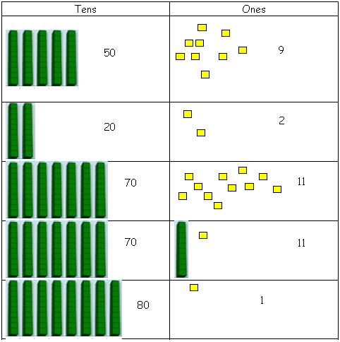

The place value materials help children understand exchanging units for tens (carrying).
Move on to bigger numbers and money amounts with the £. notation.
Stage 5- using column method.
Understanding place value is the key to developing a child’s understanding of number.
Children need to understand that they need to start with units in this method.
This method should initially be modelled using partitioning before getting to the standard written method:

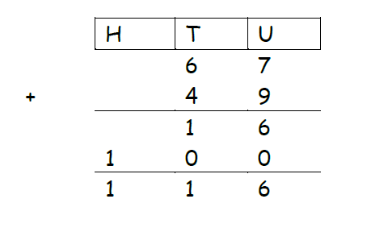
Then,
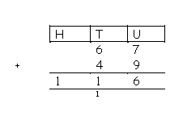
Children need to understand that when the answer in a single column is a 2-digit number, the units go in the answer box and the tens are carried over.
Children need to understand that when they can’t carry over to another column, the 2-digit number is written in the answer box.
Extend on to bigger numbers, adding more than two numbers and adding decimal numbers including amounts of money.

Subtraction
(The majority of children should be using the column method for subtraction before leaving Year 6).
Stage 1-various practical activities to ensure a conceptual understanding of what subtraction is. Children begin to record in the context of play or practical activities or problems.
Children will be learning how to subtract using different objects or toys to support them.
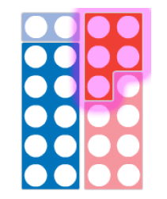
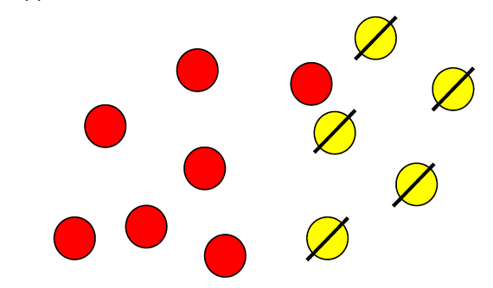
Begin to relate subtraction to ‘taking-away’.
Removing items from a set. 12 – 5 = 7 will come later after practical activities and language is secure.

Comparing a set of objects (comparison or difference) helps children’s understanding of the inverse.
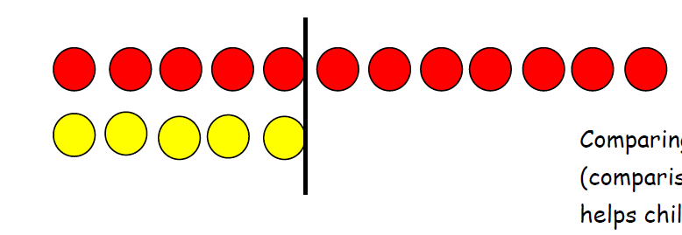
Introducing subtraction as ‘finding the difference’. Use Numicon to lay a tile on top to show the difference.
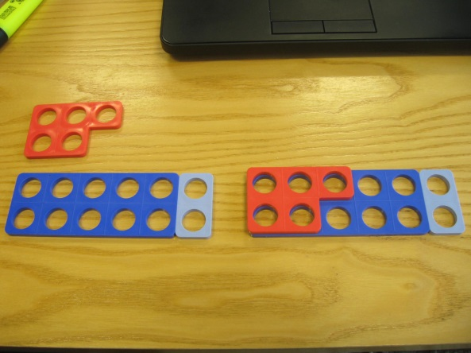
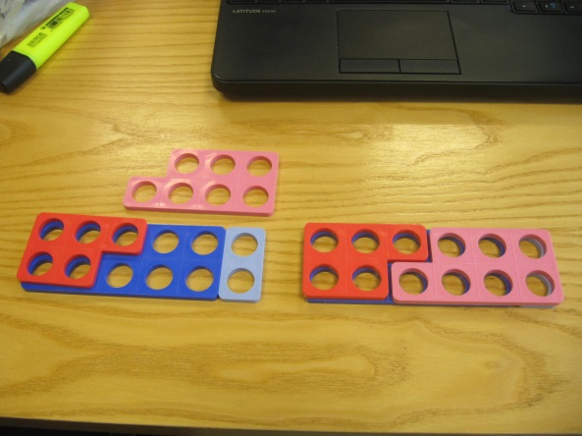

Stage 2- counting back on a number line.
This method should be modelled to the children alongside the practical resources (as shown in stage 1).
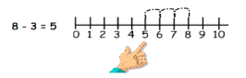

Counting back can also be modelled using a number square. Children should know that moving to left on a grid is -1 and moving up is -10. Take away 10s first and then units.
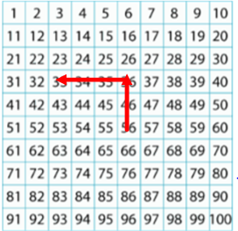

56 – 23 = 33

Subtract 9 or 11. Begin to add/subtract 19 or 21

35 – 9 = 26

Introducing the children to the inverse operation concept is essential and should be modelled together. This should be shown as:
12 + 5 = 17 and 5 + 12 = 17 so 17 - 5 = 12 and 17 – 12 = 5

Stage 3- Counting on using a number line-finding the difference.
Children will use number lines to help them find the difference between numbers. This can be supported by Numicon.
1dkjfhkjfdsfksdjhf111112

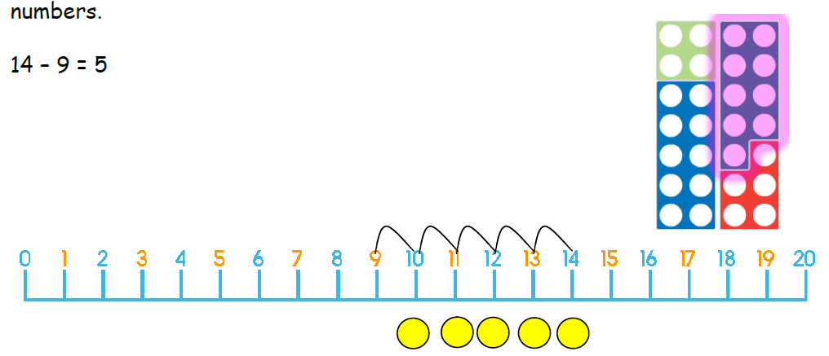
+ 5
Children become more confident at manipulating numbers.
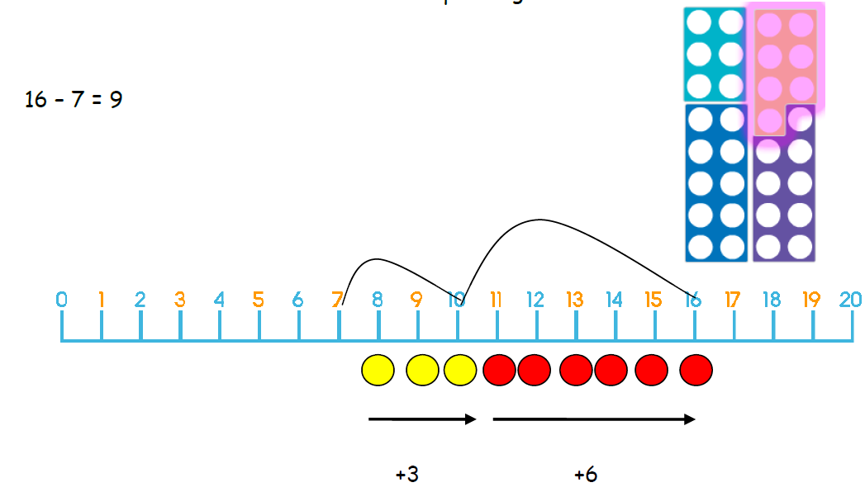

Stage 4 – Children will use an empty number line to find the difference between bigger numbers.
Children can do this by jumping on to find the difference or jumping backwards. If they are jumping backwards they need to do the jumps underneath the number line as so:
97 – 15 = 82

82 87 97

-5
If they are counting on to find the difference they need to:
- Always go to the next 10
- The 10 below the number-this can be done in 10s initially.
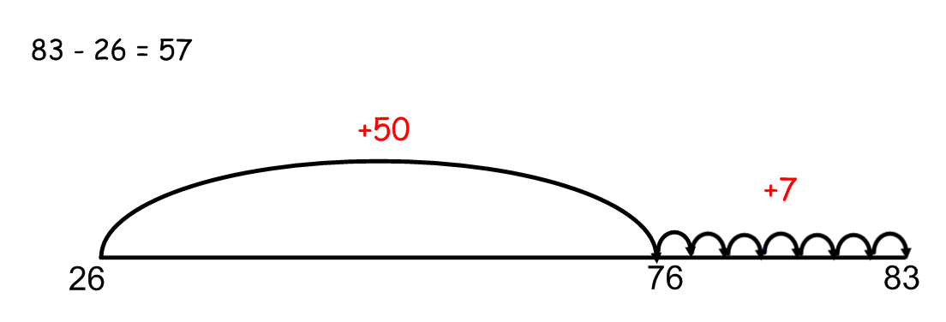

The ‘jumps’ need to be added up, above the number line. Encourage the children to add the largest number first and cross out as they go along to help to avoid mistakes.
50 + 7 = 57

This will encourage and support partitioning, which will lead the children on to partitioning in to tens and units and then recombining:
Partitioning:
67 – 34 =
60 – 30 = 30
7 - 4 = 3
67 – 34 = 33
This would then be encouraged for bigger numbers:
458 – 332 =
400 – 300 = 100
50 - 30 = 20
8 - 2 = 6
458 – 332 = 126
And then extended onto just partitioning one of the numbers:
458 – 300 = 158
158 - 30 = 128
128 - 2 = 126
So 458 – 332 = 126

Stage 5 – using column method.
Similar to addition, this should initially be modelled with partitioning:
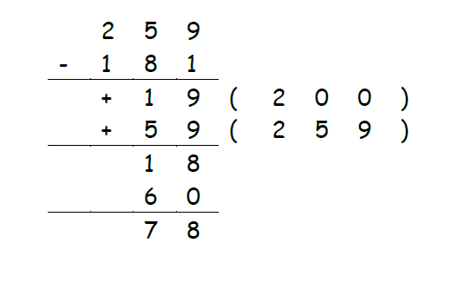
Then move on to standard written method:
35 – 24 = 11
35
-24
11

Children need to understand that if the top digit is smaller than the bottom digit, they need to exchange (borrow) from the column to the left.

672
- 36
36

Extend on to bigger numbers including decimal numbers and money. Also numbers where the children need to exchange more than once:
e.g.
6 72452
- 3637
3625
and questions like 6000-1234 =
(where they need to keep exchanging until they get a larger digit on top).

Multiplication
(The majority of children should be using the grid method for multiplication before leaving Year 6, some HA children can progress on to long multiplication, but only once secure at using grid method).
Stage 1-children understand multiplication as ‘groups of’ or ‘lots of’ and begin to use objects and practical resources to group them into a certain number.
Use any practical resources e.g. socks, cubes, Numicon, beanbags etc. to model the concept of multiplication.
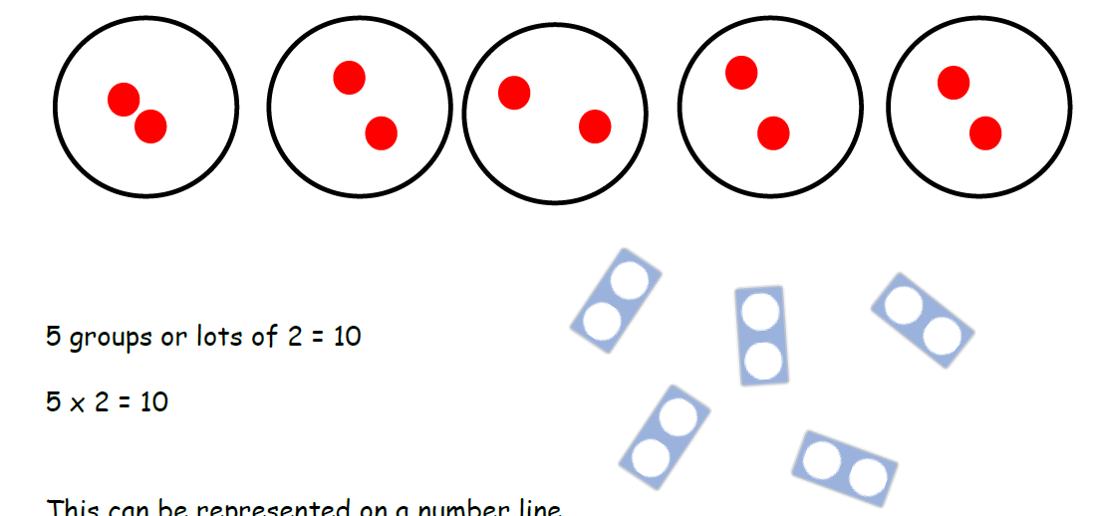

2 + 2 + 2 = 6 ( 3 x 2 = 6)
This can be represented on a number line:
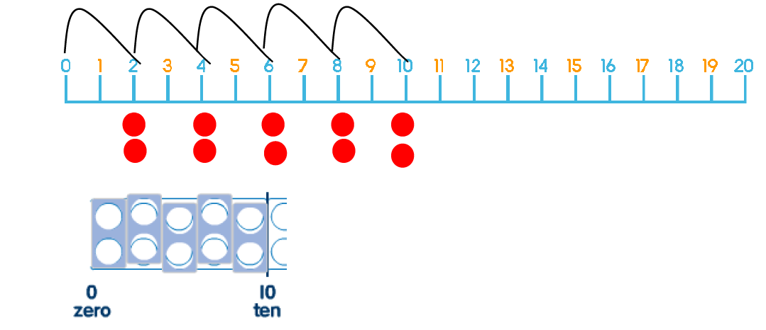

Stage 2 – using arrays and repeated addition.
Children will become familiar with using arrays to model x tables. They can clearly see the that 3 ‘lots of’ 4 is the same as 4 ‘lots of’ 3. Children need to know that it doesn`t matter which way round the sum is done (X or +) because they arrive at the same answer.


4 x 3 3 x 4
This model can help children learn and understand more difficult times tables.
For example 8 x 7:
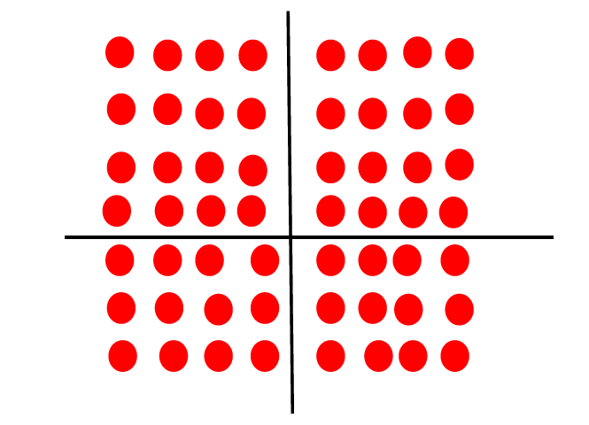
Repeated addition can be modelled using Numicon:
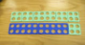
6 x 4 = 24
This can then be linked to a number line. When modelling this, a teacher should always show both of these images together (Numicon and the numberline).
Children need to know the relationship between related facts. If they know 5 x 3 = 15, then 50 x 3 = 150 and 50 x 30 = 1500 etc.

Stage 3 - partitioning for grid method.
Children need to be secure with partitioning numbers into 10s and 1s and partitioning in different ways.
Children need to use known facts and place value to carry out simple multiplications.
35 x 2 = 70
30 5

X 30 5
6 180 30 =210

235 x 6 = 1410
200 30 5
x 200 30 5
6 1200 180 30 = 1410

23 x 72 = 1656
20 3 70 2

x 20 3
70 1400 210 = 1610
2 40 6 = 46
= 1656

The children may want to show the addition of their answers in column format.
Extend on to bigger numbers and decimal numbers.

Stage 4 – long multiplication.
This stage will only be used when the children are showing a very secure understanding of stage 3. Most children will leave Y6 using the grid method securely.
35 x 26 = 910
 | 3 | 5
x | 2 | 6
 | 3 | 0 | (5 x 6)
1 | 8 | 0 | (30 x 6)
1 | 0 | 0 | (5 x 20)
6 | 0 | 0 | (30 x 20)
9 | 1 | 0
H T U

Doubling and halving:
The ‘diamond method’ should be used to show doubling and halving.
The children firstly need to partition the number, then double/half it. When they have done this they need to recombine the number by adding them together.
The children can do the inverse to check their answers.
For example:
Double 328:
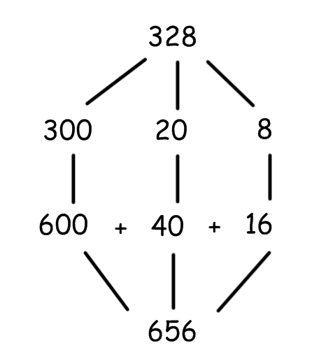
To check we can half 656:
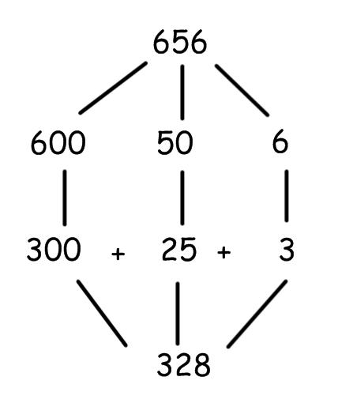

Division
Stage 1-sharing numbers into equal groups, related to everyday tasks. For example: when sharing out the milk, sharing out sweets at a children’s party, getting into teams for PE etc.

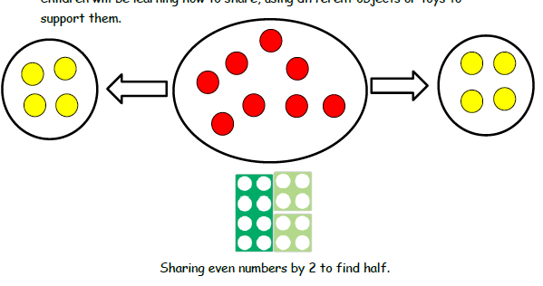

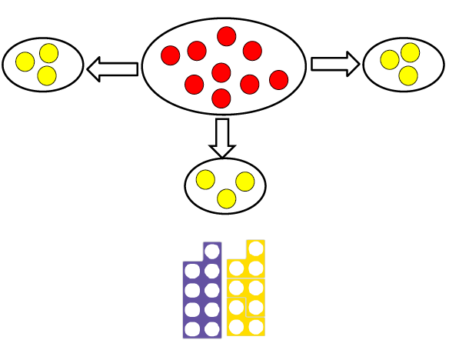

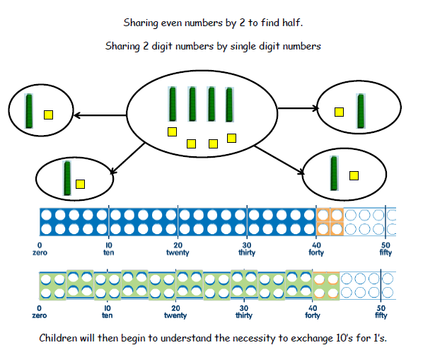

Stage 2: Grouping.
Children need to know division as ‘groups of’.
Children are encouraged to read a division question as:
“How many groups of 3 go into 12?” (12 ÷ 3 =)

Children should use practical resources to group them rather than share. This can be modelled well using dienes or unifix cubes.
30 ÷ 6 =
“How many groups of 6 go into 30?”
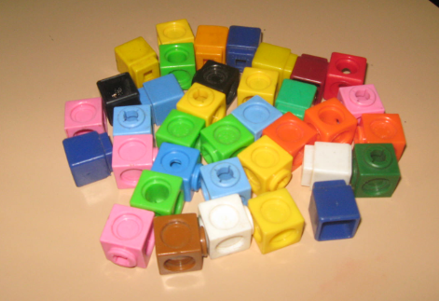
30 unifix cubes
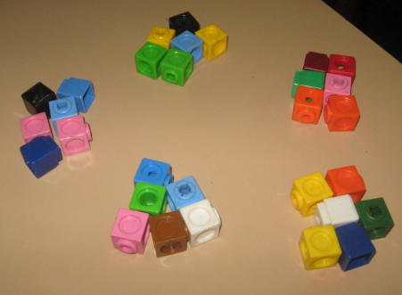
Separated into groups of 6.
The answer is how many groups of 6 are there? 5

Stage 3- Using numberline alongside practical resources to count how many groups of a number go into a bigger number.
Children to use Numicon to set out the biggest number. They should then pick the tile for the number they are dividing by to see how many times it fits on top.
For example:
24 ÷ 6 =
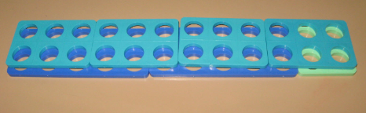
They then count how many tiles fit exactly into the bigger number, to find their final answer.

They can then apply this to a number line, showing the jumps clearly and how much the total is each time.
They should count the jumps to find their final answer.
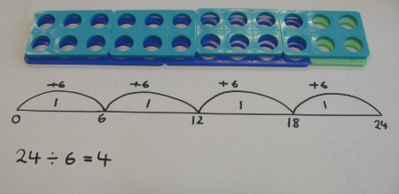
Encourage children to include all this working out in their books to show they are secure on the method.

Stage 4- using expanded numberline method using key times tables facts.
Children to use their times tables knowledge to help them make bigger jumps on the number line when working out bigger numbers (e.g. 4-digit ÷ 1/2-digit numbers)
105 ÷ 3 =
“How many groups of 3 go into 105?”
- Children will write the key facts of that times table in a key fact box and use that to create bigger jumps. For example if they know 20 x 3 = 60 they can make a jump to 60 by writing 20 in the jump.
- Children need to make sure they clearly write down what they are jumping up in and what they are adding each time.
- They reach their final answer by adding up the numbers inside the jumps, which will show how many groups of 3 go in to 105.

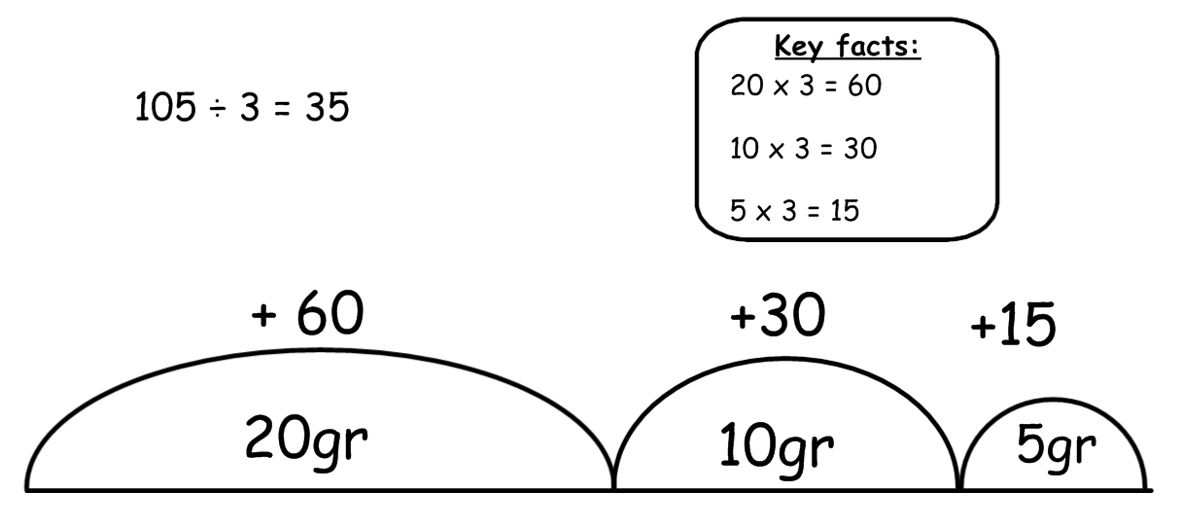
And with a remainder:
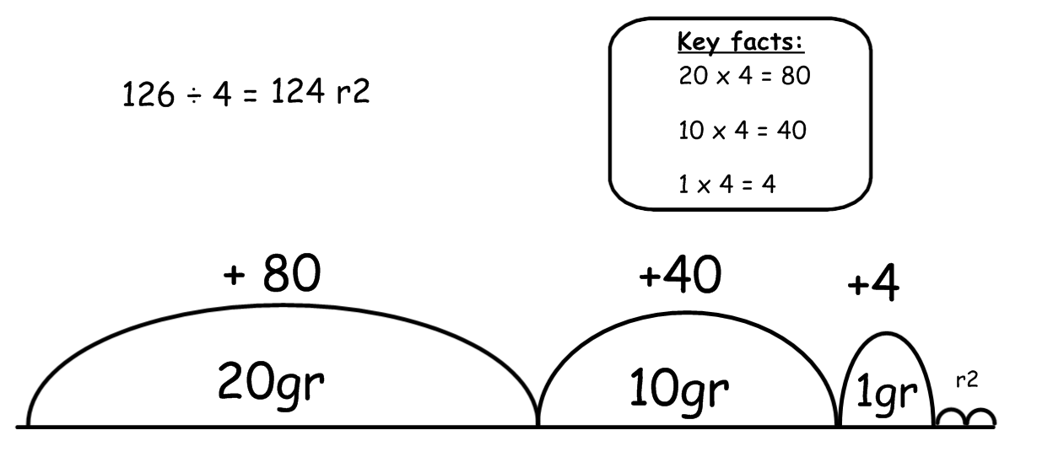

Stage 5- Standard written method (long division).
The majority of children should be using this by the time they leave Year 6.
Children should not be moved on to this until their understanding of remainders and what we do with remainders, is secure.
*You may want children to write the remainders that they have carried over in a different colour initially, to clearly show the difference between HTU.
If children have a remainder at the end they must show this by writing: r4.
When dividing by 1-digit it should be set out like this:
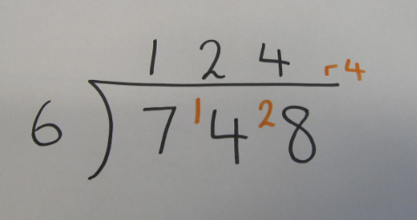
Once children are secure on this method, they should then move on to dividing by 2-digit numbers using the chunking method.
When children are dividing by 2-digit numbers, they need to use the chunking method shown below:


